# 

**MSDA Capstone**

**Regression Analysis on home prices in California: A comparison of performance among various machine learning techniques**

Elesmy Orellana

Western Governors University

**Research Question**

The primary aim of this case study is to predict housing prices using the provided features in the dataset. While answering the research question, ‘Is there a relationship between median house value and median income?’ The justification for this question is to identify a significant relationship between the median house values and median income variables. The goal is to create a machine learning model which can accurately predict home prices in the state of California. Median income can be an important feature because earnings can identify the range of home values that people buy. A district's salary range might help predict the value of homes. How many people are earning could define the type of house they can afford. If most people are making a specific salary range, they will lie within a median home value range.

***State the Hypothesis***

* ***Null hypothesis:*** There is no significant relationship between the median home value and median income.
* ***Alternate Hypothesis:*** There is a significant relationship between the median home value and median income.

Knowing the price of a home regarding the physical features of the house is important. In a house, many factors are accounted for when estimating a price. Various features can identify the value of a home. For example, ocean proximity, number of rooms and bedrooms, age of a home, etc. The more rooms a house has, the more likely it will be more expensive.

This dataset is important because “instability in the housing market necessitates the need for better methods for assessing housing prices. Consequently, the predictive accuracy of housing models has gained much attention among scholars and has been extensively studied.” (Komagome-Towne, 2016)

A model which produces accurate home prices could allow organizations, stakeholders to take advantage of many opportunities. Investors and businesses could plan and ensure that they have finances. Preparing strategically enables them to increase profits and minimize losses.

**Data Collection**

Kaggle is a website that provides many resources for professionals, students, or anyone interested in data science, machine learning. They provide many tools, including datasets.

The original dataset is from the 1990 Census for the state of California. The dataset is focused on housing features. Although the data is outdated, it is useful for machine learning applications and testing. There are various versions of this dataset. Sklearn has a version slightly different, with only 8 features. In search of a housing dataset, many challenges were faced.

Zillow has updated available datasets which can be accessed using an API key token. This was the original approach, but to comply with the website's data governance and privacy rules, Kaggle was used instead. This approach eliminates any risk of legal issues.

On Kaggle.com, the California housing dataset is publicly available. It has 10 columns and over 20,000 rows. All except for the ‘Ocean proximity’ column are numeric integers. Each row is represented one block in California. Longitude and latitude are the distances, either west or north of the block. Each observation comprises one block or population. housing_median_age, median_income, and median_house_value are the median ages (years), incomes (10,000 USD), and housing price estimates (USD) for each block. total_rooms, total_bedrooms, population, and households reflect the total number of rooms, bedrooms, people, and housing units in each block.

An advantage of this data gather process is that it’s easy to extract and acquire the dataset. It simply needs to be downloaded to a PC. The disadvantage of this approach is that looking for a dataset can be time-consuming, in-depth research is necessary to see if the data is useful and usable. The data did require some cleaning, conversions, and imputations. The data was complicated as there are gaps and there are calculations that need to be accounted for.

|  |  |
| --- | --- |
| **Feature** | **Data Type** |
| longitude | Continuous Numeric (IV) |
| latitude | Continuous Numeric (IV) |
| housing_median_age | Continuous Numeric (IV) |
| Total_rooms | Continuous Numeric (IV) |
| Total_bedrooms | Continuous Numeric (IV) |
| population | Continuous Numeric (IV) |
| households | Continuous Numeric (IV) |
| median_income | Continuous Numeric (IV) |
| median_house_value | Continuous Numeric (DV) |
| ocean_proximity | Categorical Object (IV) |

**Data Extraction and Preparation**

The dataset was extracted and preprocessed using the Python programming language. The external program, *Google Colab* was used to achieve a high-performance speed. ‘Colaboratory, or “Colab” for short, is a product from Google Research. Colab allows anybody to write and execute arbitrary python code through the browser, and is especially well suited to **machine learning, data analysis, and education**.’ (Google.com) One advantage of using Colab is the high-ram speed and a disadvantage is that “Google Colab has a ‘maximum lifetime’ limit of running notebooks that is 12 hours with the browser open, and the ‘Idle’ notebook instance is interrupted after 90 minutes.” (Nurfikri)

The first step was to extract the data from Kaggle.com, download and save it on the local computer hard drive as an Excel file. The file was named ‘cali_housing.xlsx’ then uploaded to google drive. Next, the necessary libraries and packages were imported. Third, the Pandas package was used to create the data frame and store it in an object, named ‘df’.

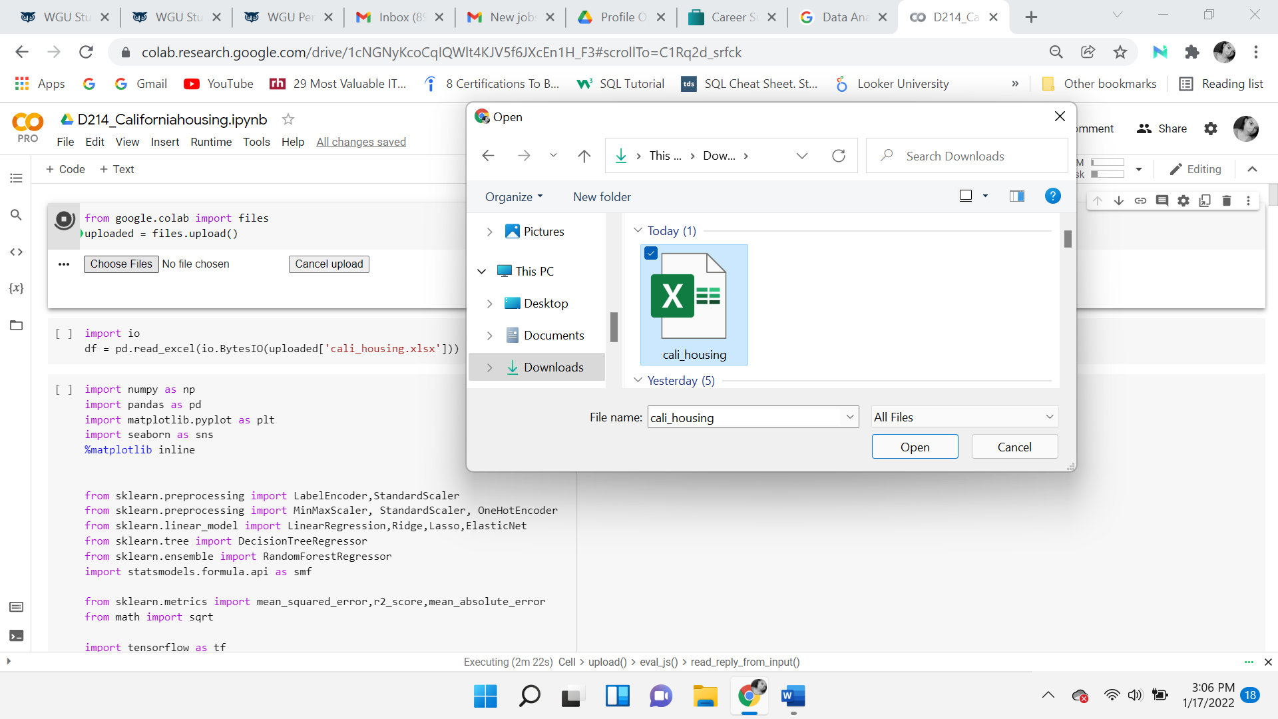

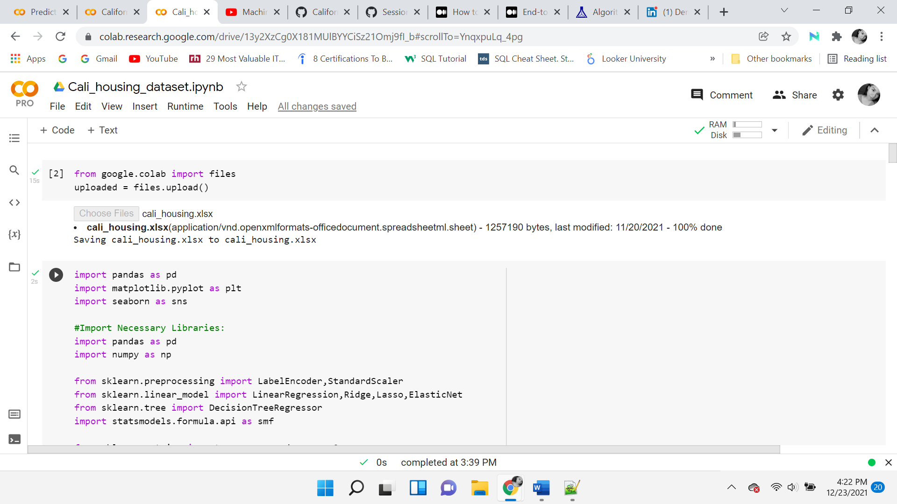



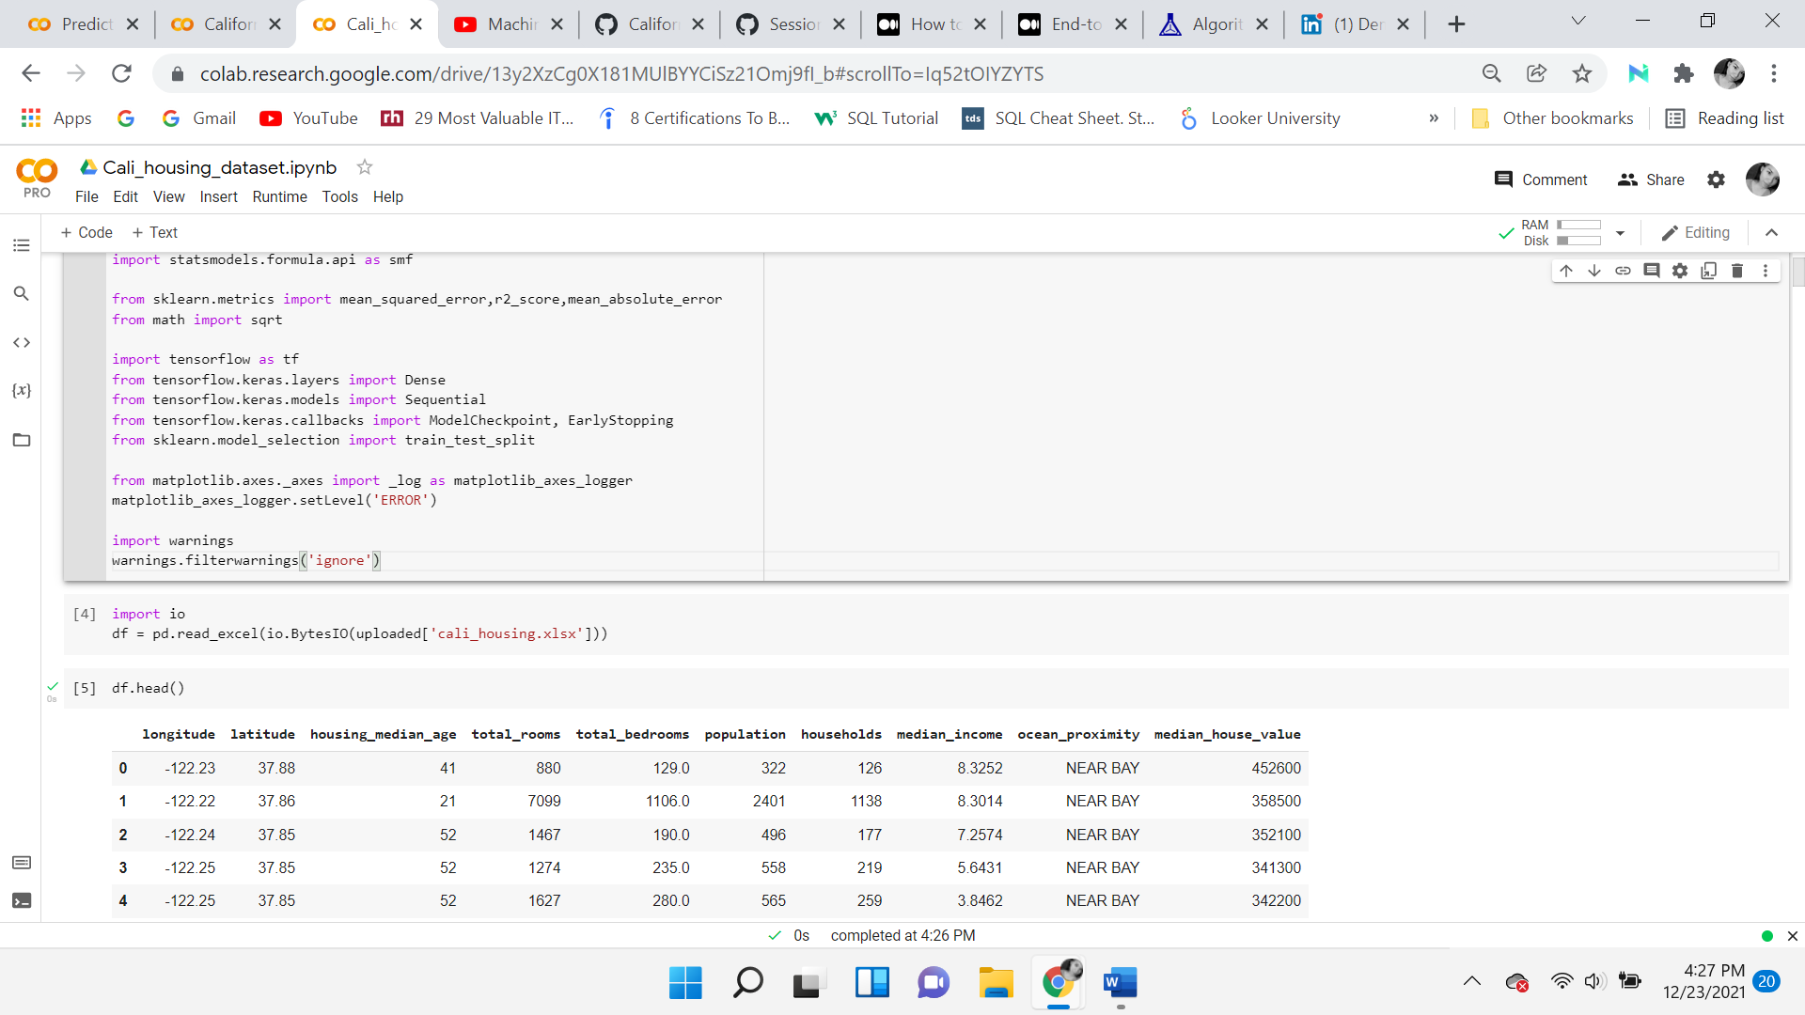

A variety of tools were used in this project. The advantage of using Python is that it is a free and open-source tool. “One of the key reasons why most programmers and even data scientists are beginning to prefer Python over R is due to its ability to rapidly perform most data science tasks with relative ease. Another area where Python outshines R is that it can perform comparatively faster. Other factors against R can include a lack of features, such as unit testing and insufficient code readability.” (Costa, 2020) A disadvantage of Python could be that it “is an **interpreted** language and **dynamically-typed** language. The line by line execution of code often leads to **slow execution**.” (Vidvan, 2021)

Many resources are available for beginners to gain a better understanding. Both Pandas and NumPy are used to work on data structures within the notebook. Beginning with. head(), gives a quick look, showing the first 5 rows of data.

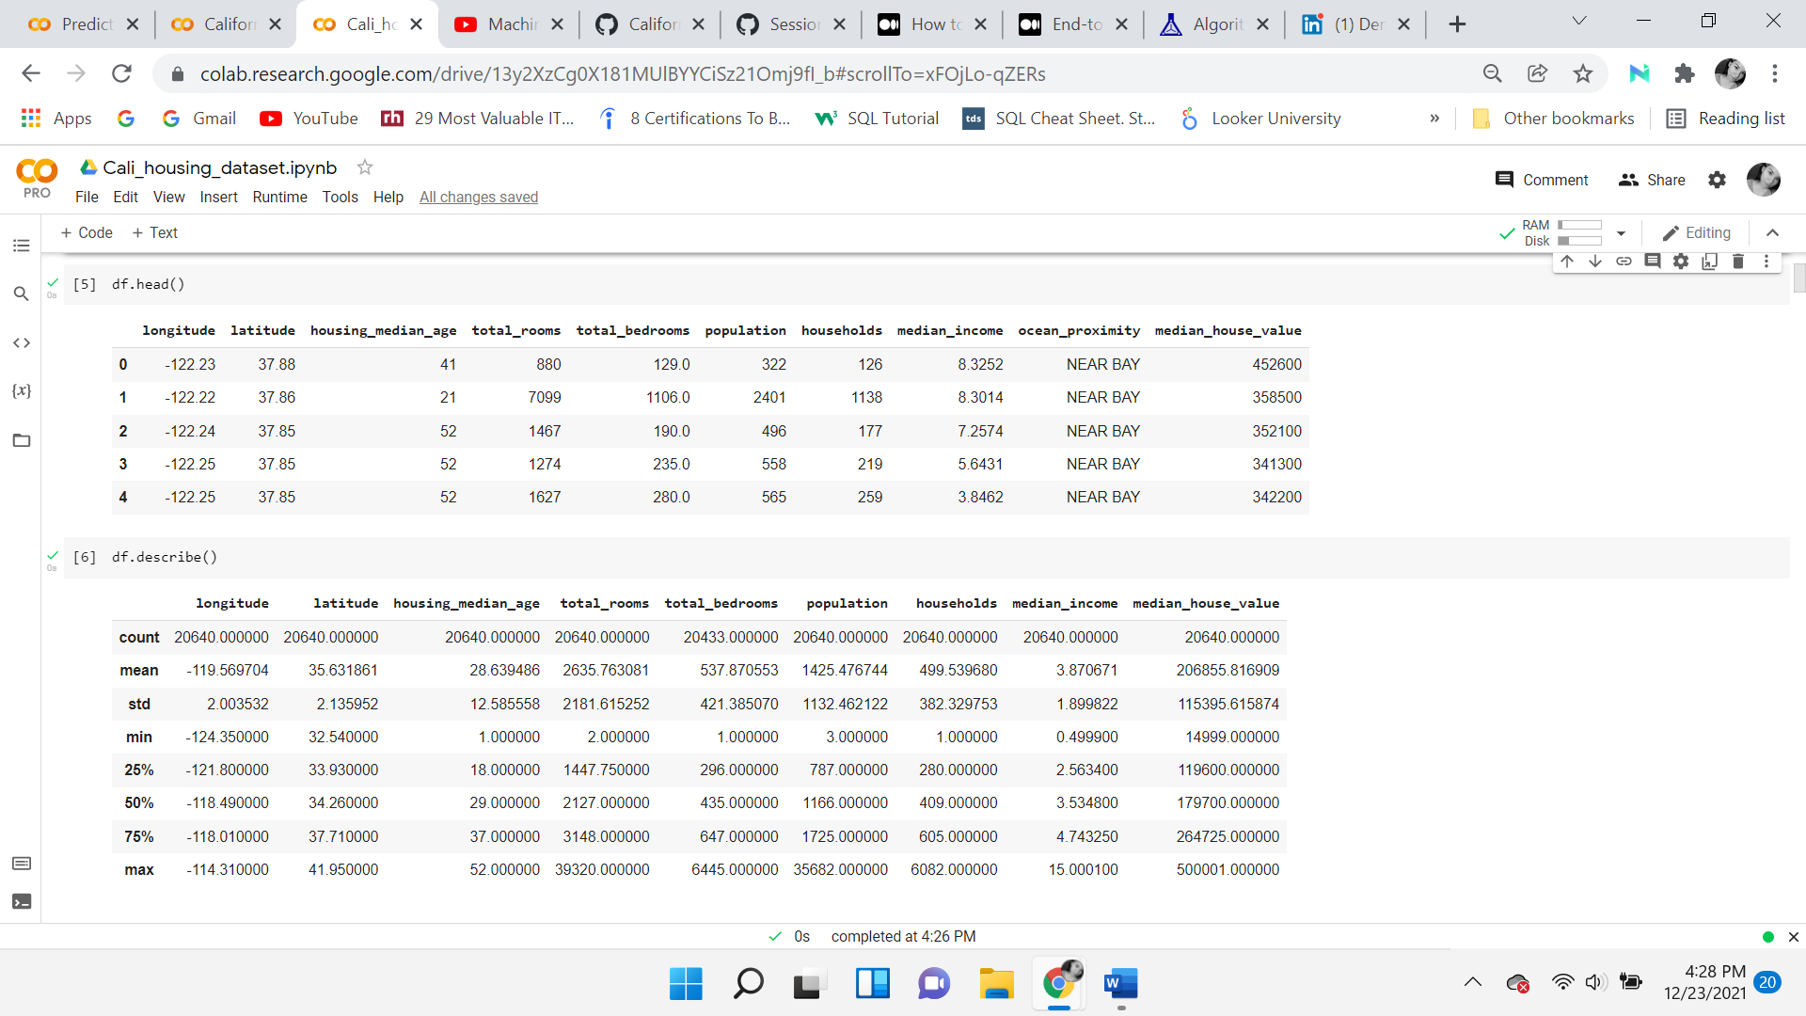

**Data Preprocessing**

In the preparation phase, the goal is to get an initial understanding of the dataset. While loading the dataset finding any missing values, duplications, or outliers. When performing basic summary statistical functions, identifying the datatypes. One of the first things that stand out is that total bedrooms and total rooms are in the hundreds and thousands, given each row is a district or a block, this makes sense. Longitude, latitude, and house median age seem to be fine. 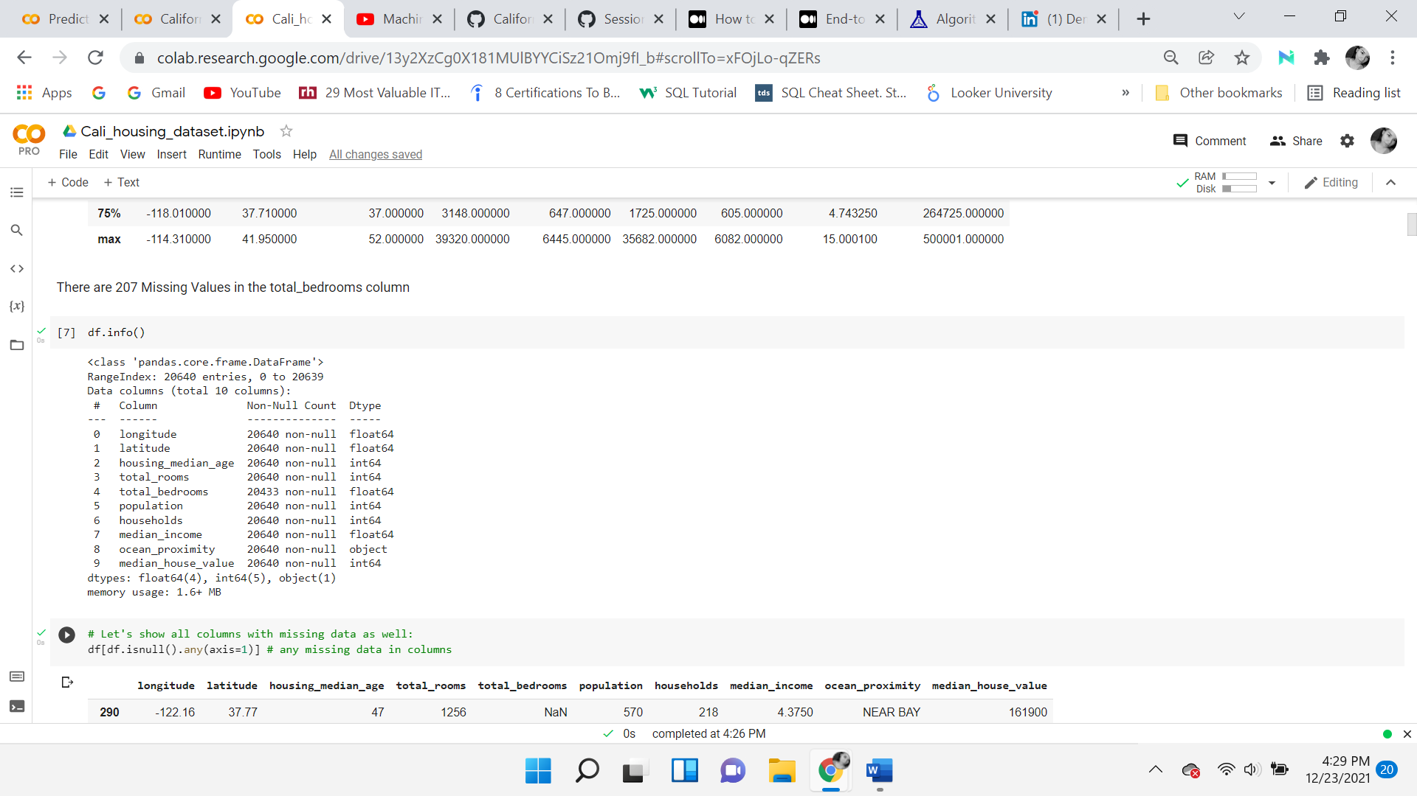They do not have any missing values or extreme abnormalities.

The techniques used to perform basic summary statistical analysis were Python functions such as .info and .describe. *Info* provides each variable's data type and null count. The output shows that every row except for total bedrooms has a total of 20640 values.

***Handling Missing, Duplicated, and Outliers***

The Python function *Df.isna().sum()* was used to show the total number of values missing, which is 207. The total bedrooms, missing values were handled with the function *fillna* using imputation by inputting the overall average of the variable. Followed by checking if there were any duplicated values in the data frame, the output returns false. False indicates that there are no duplicated values in the dataset.



Looking at the population and households, initially, it’s not obvious which unit of measure they are presented in. Households are the number of people living together, within a block, with a mean of 499. The average population is 1425, which makes sense to say that it’s the total number of people living in a district. Given that the number of people in one block range from 600 to 3,000. In median income, the minimum income is 0.4999 and the maximum is 15.0001, with an average of 3.87. It’s obvious, the median income has been scaled and capped.

**Data Exploration**

The data preprocessing phase comprises data cleaning, data transformation, and data reduction. Exploring the data begins with Exploratory data analysis techniques. EDA consists of visualizations such as scatterplots, histograms, and box plots. These are used to better understand the data and detect any outliers. To get familiar with the dataset and provide validation through visualizations. An advantage of the exploratory data analysis process is that the visualizations can provide valuable insights, helps select important features, discover patterns, and it's an effective way to detect abnormalities and outliers. A disadvantage of EDA is that if they are not performed properly, they can be misleading and lead to incorrect conclusions. The key to the Data Exploration process is to understand the nature of the data, relationships, such as central tendency, the measure of spread, distributions, and variability.

***Ocean Proximity***

Beginning with the only categorical variable, ocean proximity. against the target variable, the higher-priced homes are both ‘NEAR BAY’ and ‘NEAR OCEAN’. Both categories appear very similar but ‘NEAR OCEAN’ is slightly lower. The minimum and maximum, are the same because the median home value caps at 500k. The ‘INLAND’ category is the smallest, inferring that they are less expensive, also displaying many outliers. ‘ISLAND’ does not reach the 500k cap. Although it only has 5 values, it seems to have more expensive homes, as its minimum value is the highest of all the other categories.

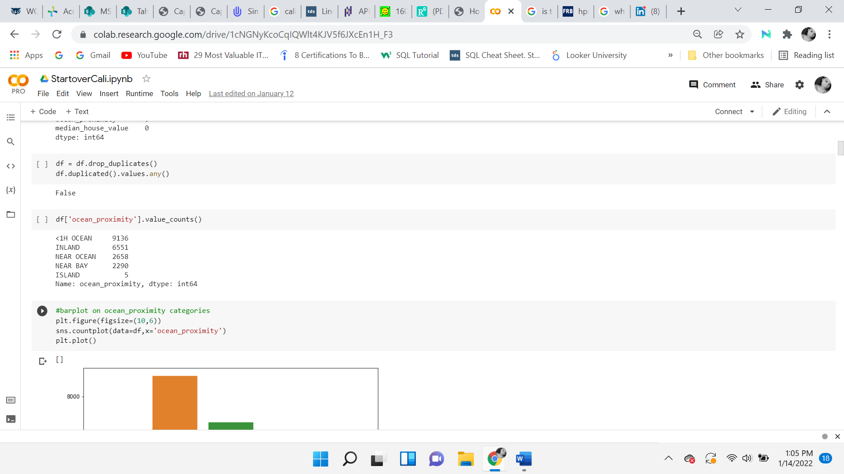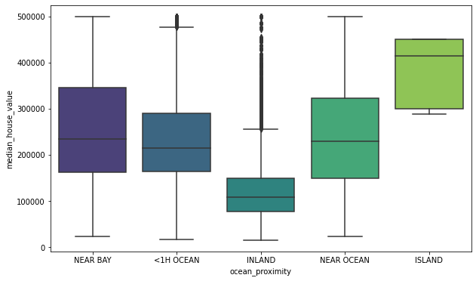

**Boxplots**

Boxplots have four quartiles and allow us to see the range of the data. The interquartile range (IQR) is represented as the blue box. It is the measure of statistical dispersion and variability based on dividing a data set into quartiles. The whiskers on the sides of the box connect to the minimum and maximum values. The lowest quartile is the first, the second is the median, the third quartile is the upper range, lastly is the fourth quartile. The lines outside of the blue box are the minimum value (to the left) and maximum values (to the right). Anything beyond the minimum and maximum lines is considered an outlier. Outliers are represented in black dots outside of those lines.

***Identifying Outliers***

In median house value, the dots outside the normal range are so close together that it’s hard to identify the dots. There are clear outliers in households, population, total rooms, and total bedrooms. The median home value outlier will be removed after the log transformation. Other variables will be transformed and outliers will be removed in the transformation process.

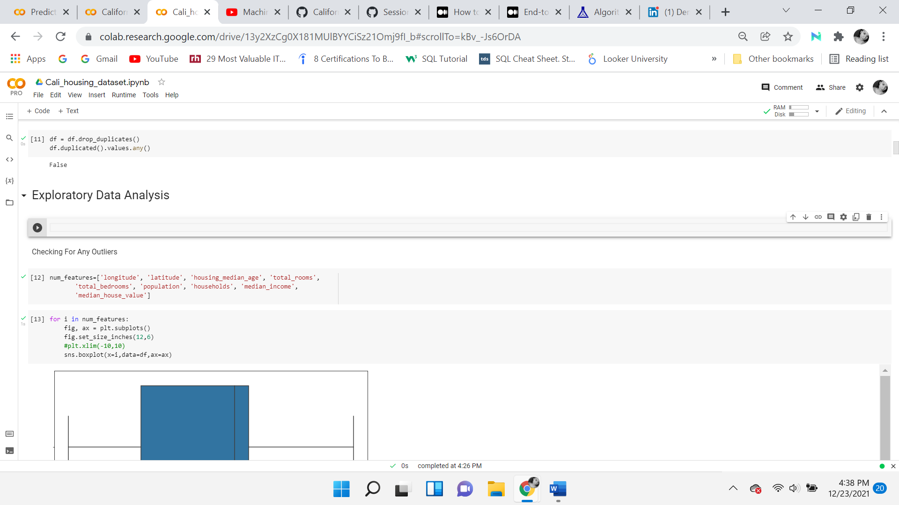

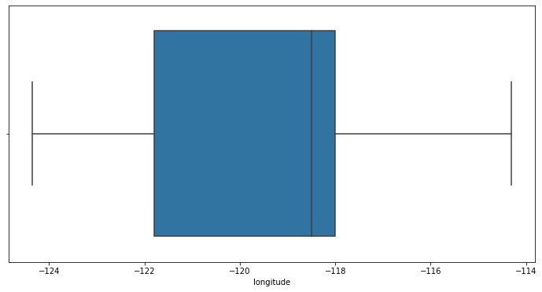

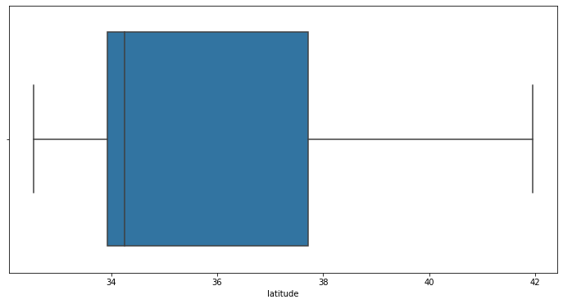

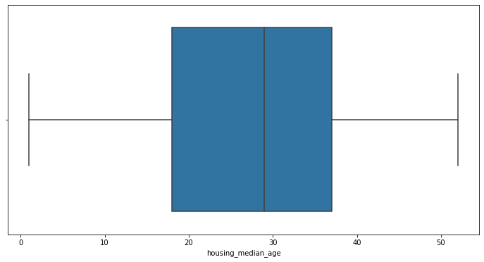

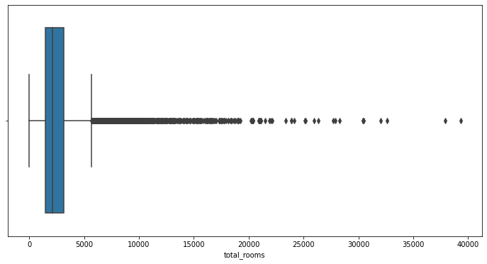

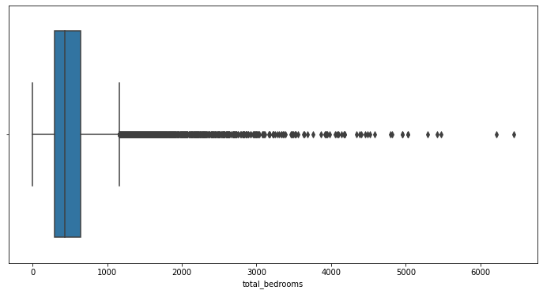

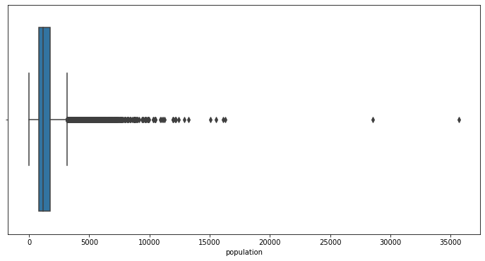

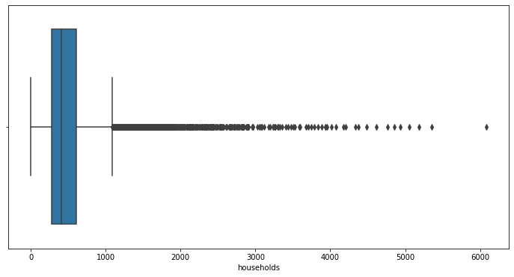

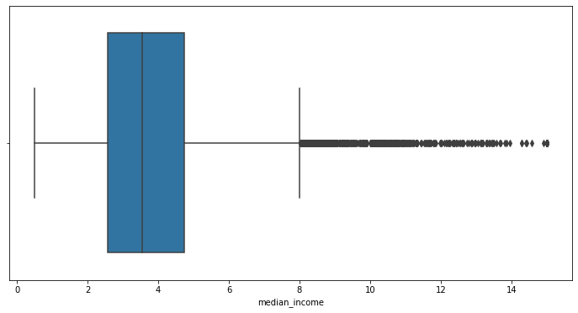

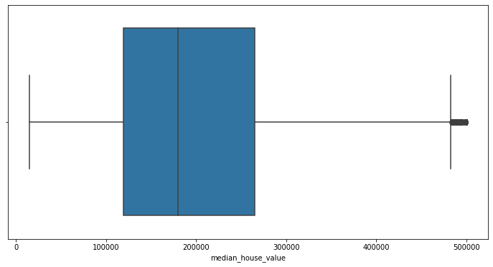

**Geographic Visualization**

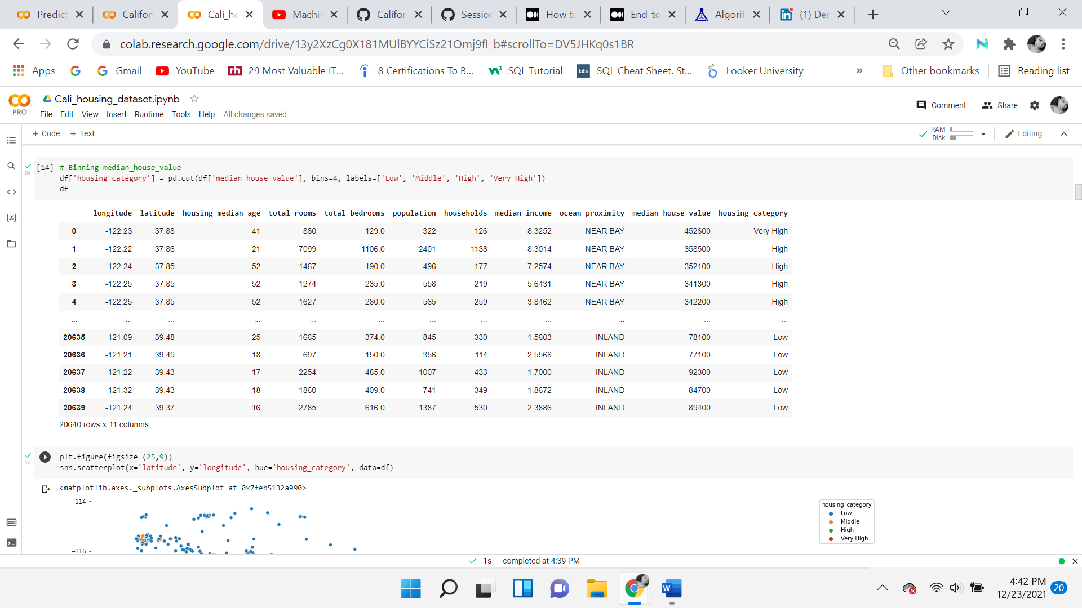

A new category ‘house category’ divides the median house value into four equal parts. The four bins are low, middle, high, and very high. Binning the column allows for identification of where the latitude and longitude lay on the map of the state of California. The first visualization shows that the most expensive homes (color black) are on edge of the map. This display points out that the housing price is very much related to the location and the population density. The houses on the edge of the map, closer to the ocean, are more expensive.

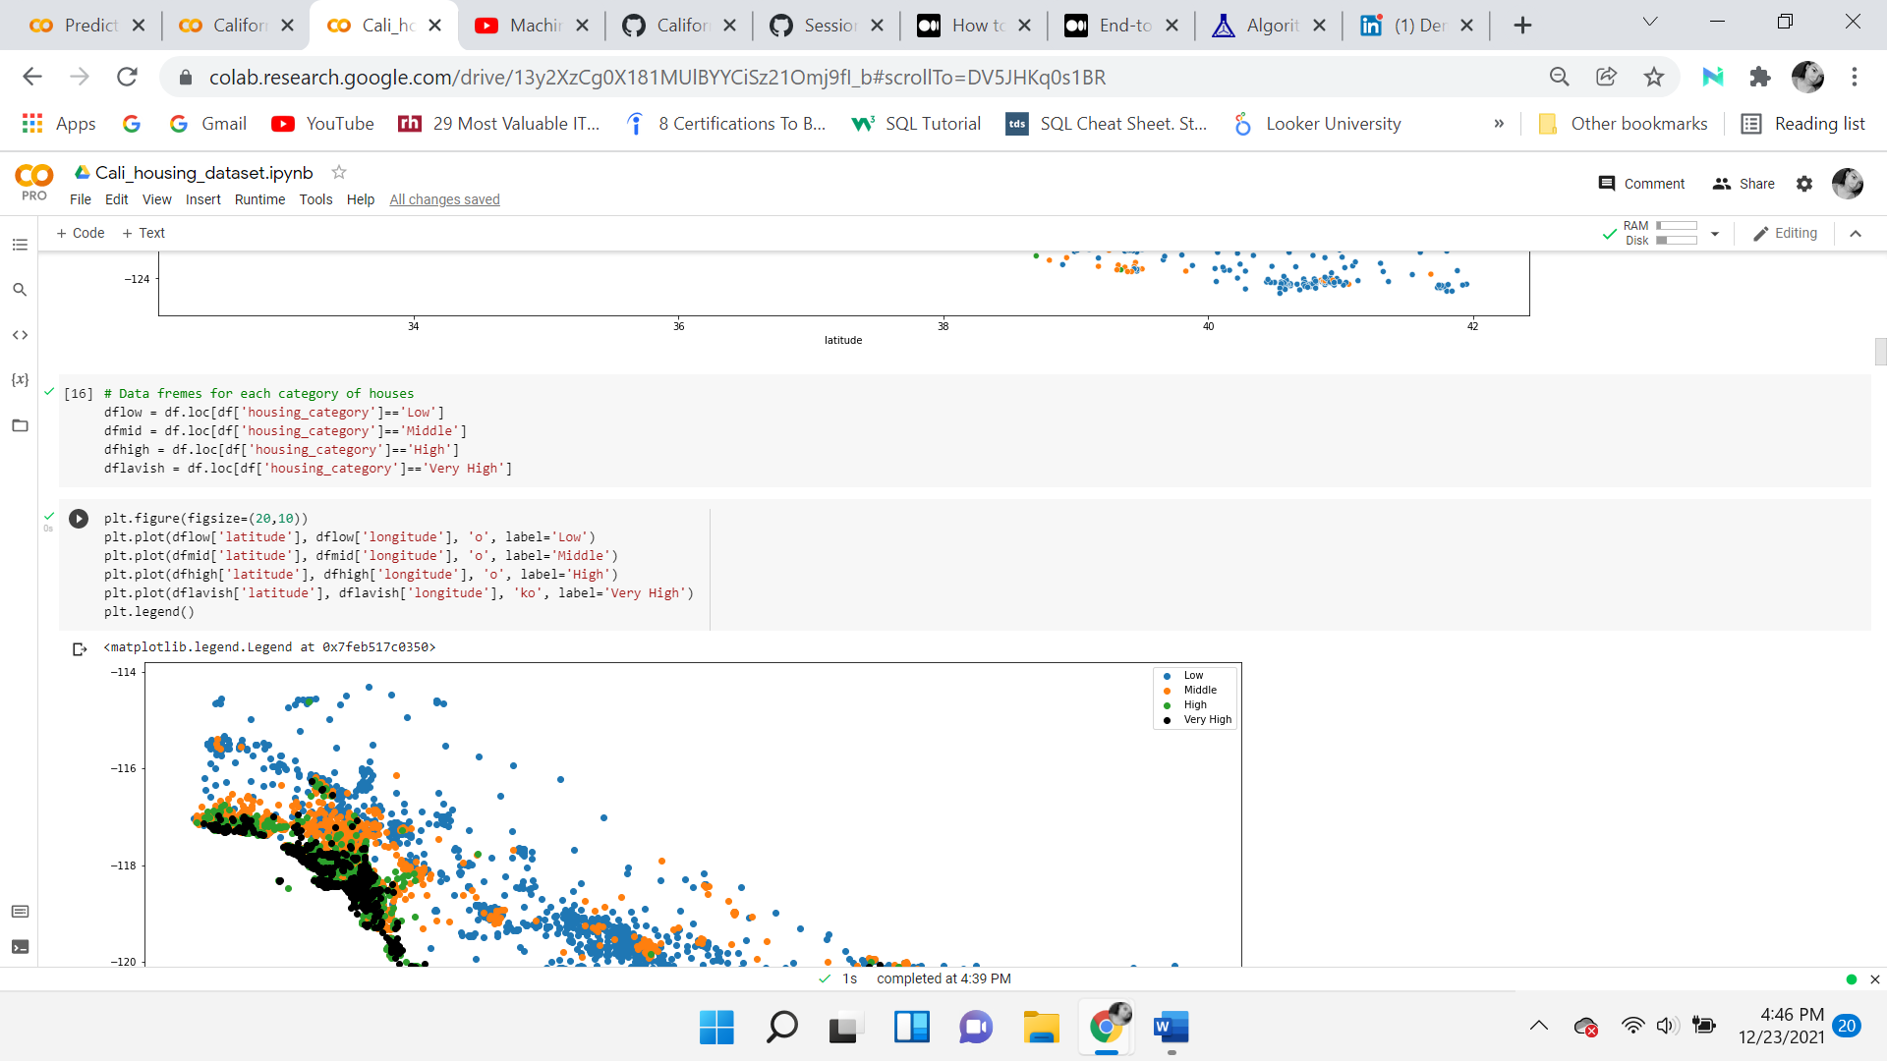

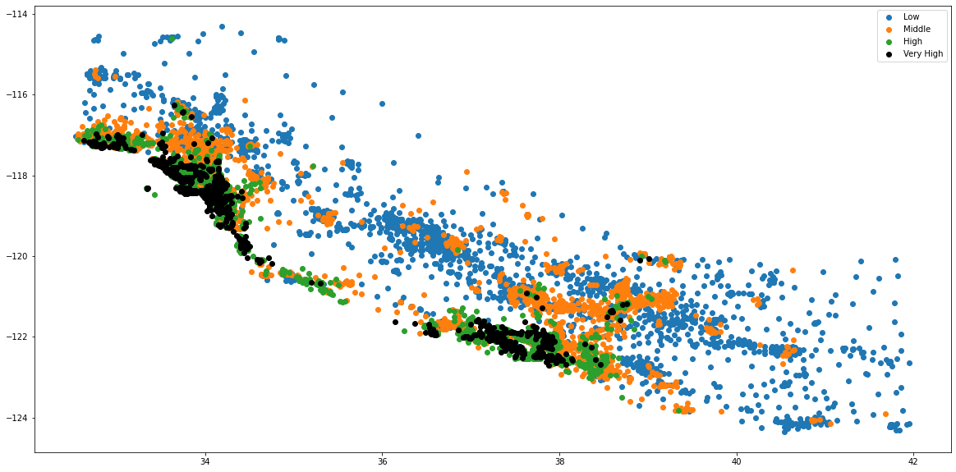

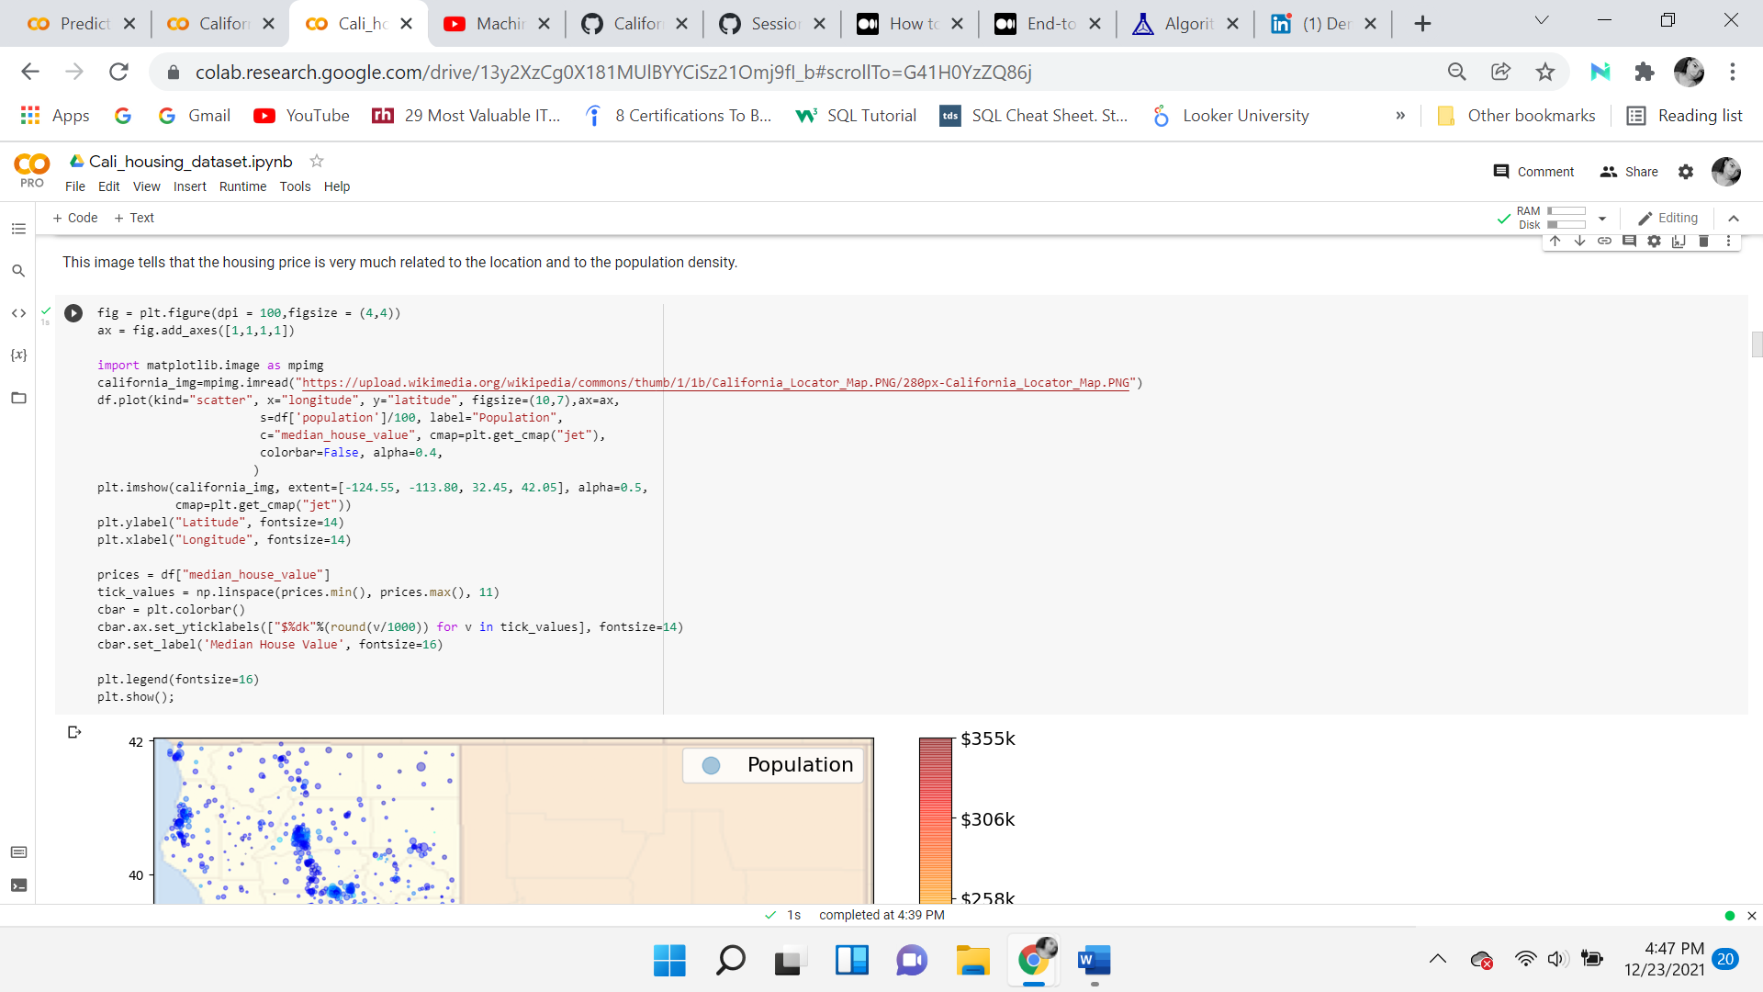

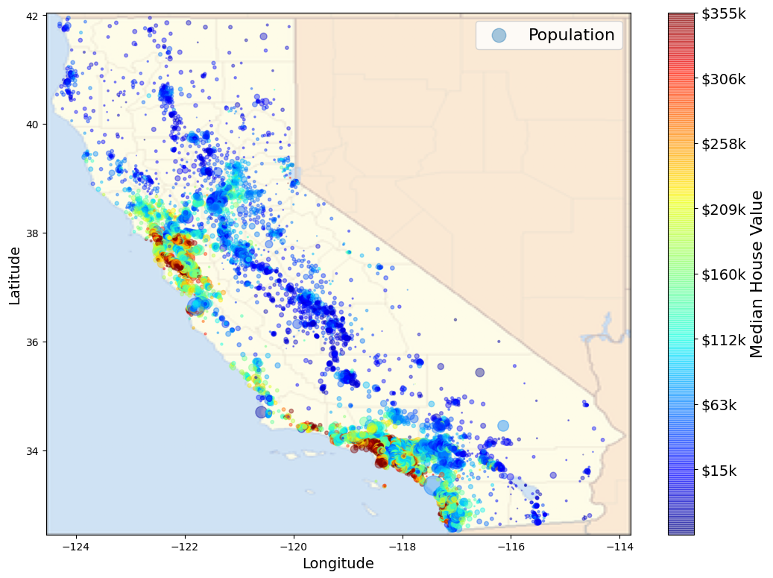

For enhanced visualization, the map was found from the Wikipedia website and used as the background of the data points. Most of the data points lay between $15k and $355k, again identifying that the most expensive houses are closer to the ocean. Light blue circles on the map are used to identify population areas. There is a value which is 500k. This capped at the value is not presented in this map, as it is considered an outlier. Looking at the map, there are clusters of red, orange, yellow that stand out in two sections, near the pacific ocean. These coordinates are near San Francisco (37.7749° N, 122.4194° W) and Los Angeles (34.0522° N, 118.2437°). Moving to the North-East home values seem less expensive.

**Histograms**

Univariate analysis is analyzing a single predictor variable. Bivariate is comparing two variables. Multivariate analyzing the dependency of two or more variables.

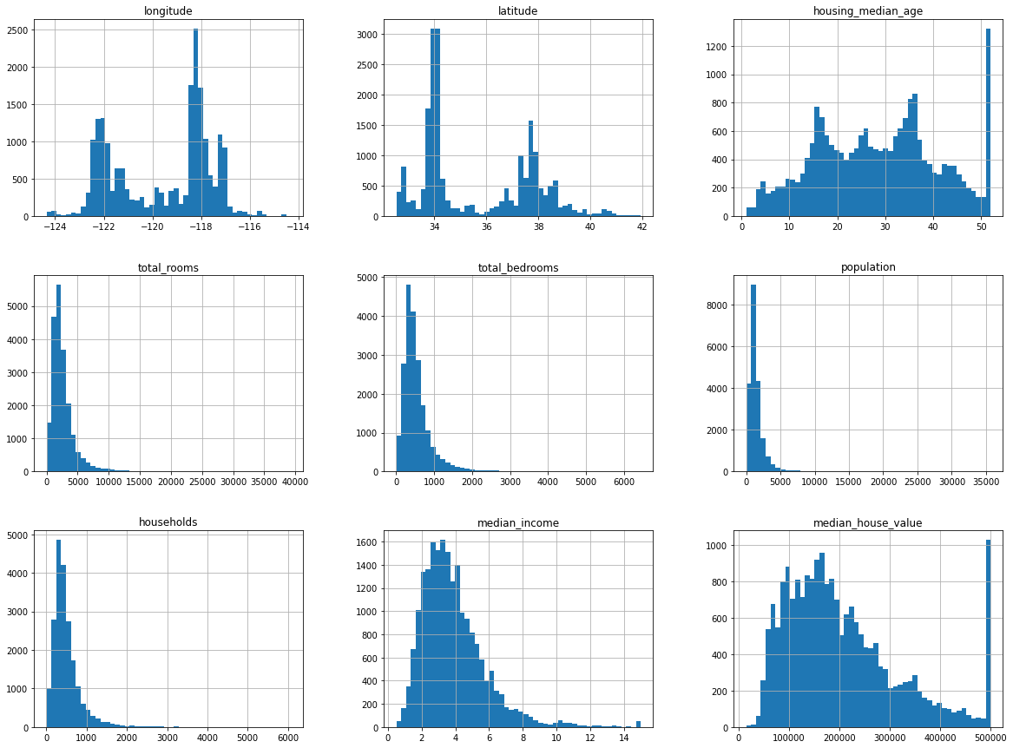

Histograms can identify the skewness and kurtosis to see how the data is distributed. Skewness is the measure of symmetry and Kurtosis is whether the data are heavy or light-tailed relative to a normal distribution. They are used for finding any outliers, odd patterns, and axis scale. The shape of the distribution alone can say a lot. Ideally, a normal distribution is desired which has a skewness of 0 and kurtosis is 3.

The first noticeable objective is that none of the variables are normally distributed. A normal distribution is usually shaped like a bell curve, large in the middle, going down, creating two tails on both sides of the graph. A normal distribution is a clear indicator that the mean, median, and mode of equal or nearly equal. The visualization indicates that none of the measures of central tendencies are equal.

Median income seems to be positive right-skewed, which usually means that the mode is the highest value in the visual representation, the mean is greater than the median. The outliers are on the right side of the graph.

As mentioned above, The median income doesn’t seem to be presented in US dollars and but this is because the feature is scaled and capped. 15.0001 for the highest median income and 0.4999 for the lowest median income. In machine learning, preprocessed attributes are common to work with.

The housing median age and median house value are also capped. Several of the histograms are heavily tailed and extend farther to the right. The median house value has an odd peak with is at the maximum value at 500k, which is considered an outlier. It is rightly skewed and shows a heavy tail, meaning outliers. The housing median age is similar to the median home value in that it has that odd peak that stands out (an outlier). It also confirms that the cap is on the maximum value. It is showing randomness with a lot of gradual peaks throughout the distribution.

The longitude and latitude variables are consistent with the expectations. As there are bi-modal peaks centered around the locations of the San Francisco Bay and the Los Angeles areas. The population distribution is also as expected as there is a peak and it’s assumed to be caused by the presence of more people in the Los Angeles area.

**Scatterplot Matrix**

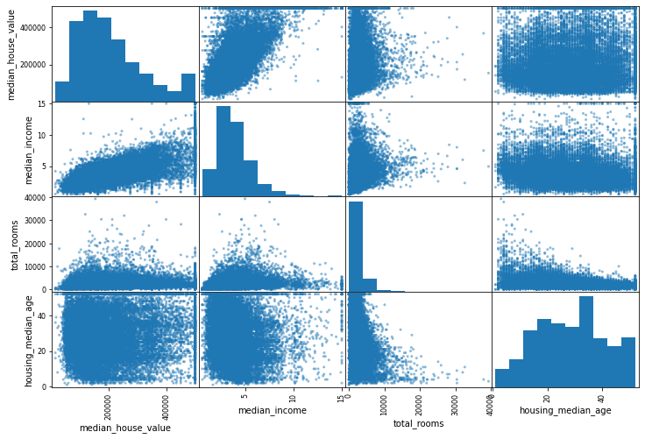

Scatterplots are useful for identifying a relationship between two variables, known as bivariate. Reading from left to right and seeing if any trends are seen. They can also be used for a visual check of multicollinearity. In this matrix, the most useful presentation is considered the median income and median house value relationship. To further examine the distributions of the target variable against the independent variable a separate comparison is displayed.

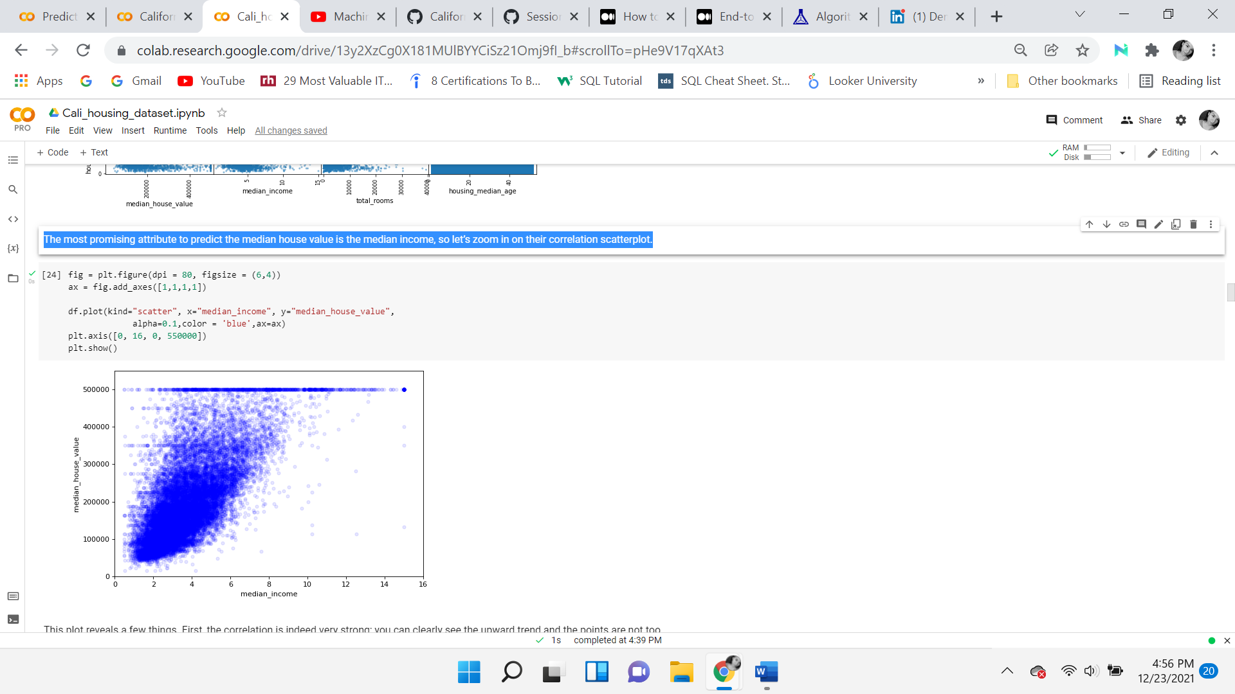

***Median house value VS median income***

At first glance the correlation is strong, there is a clear upward trend, and the points are not dispersed. There are a few horizontal lines in the plot: one clearly at 500,000, one at 450,000, another one at $350,000, and a few others. This is probably due to the scaled and capped features of the target variable.

**First Correlation Heatmap Matrix**

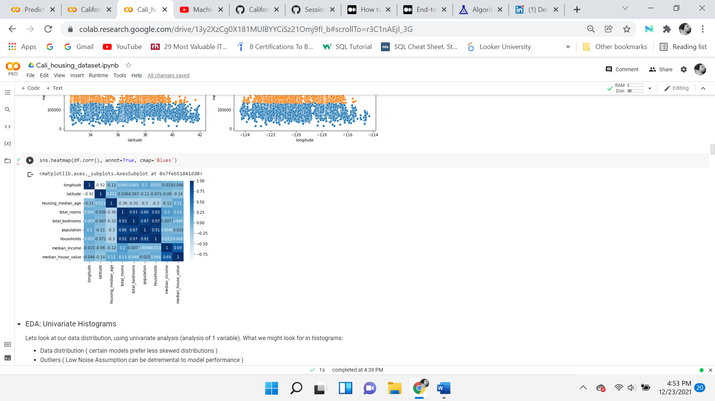

In this correlation matrix, the variables are compared against each other. In the center of the heatmap in dark blue is a square. This square displays a strong correlation of above 0.80 for four variables. The strong correlation is among the household, total bedrooms, total rooms, and population variables. Longitude and latitude are negatively correlated. The target variable which is median house value is strongly correlated to median income as previously noticed in the scatterplot.

The total rooms, total bedrooms, population, and the households columns are considerably correlated but don't explain or provide much insight for the median home value target variable. The median income is most correlated with median home values, followed by total rooms, housing median age, and latitude.

**Data Transformation**

The data transformation phase techniques consist of feature engineering, log transformations, stratified sampling, normalization, and standardization. A second correlation heatmap and calculations are displayed to see the differences after new attributes are added to the dataset. An advantage of these techniques is that they make them better organized and easier to understand. A disadvantage is that certain transformations may not be necessary and may cause information loss.

**Feature Engineering**

Feature engineering is performed on the various columns, this will help normalize the data. The columns total rooms, total bedrooms, households, and population are highly correlated. Before feeding this data to the model, these attributes should be combined. For example, the data does not state how many households are within a district, therefore the number of rooms in an entire block is not helpful. The number of rooms per household is of more use, this calculation can be achieved by dividing total rooms by households. Transforming input features to be more useful for the model. Before making any changes, a copy of the original dataset is made, named df1. Perform feature engineering by creating new features. The new features are as follows:

* 1. Rooms_per_household, which is the total_rooms divided by house_holds.
  2. Bedrooms_per_room which is total_bedrooms divided by total_rooms
  3. Population_per_household which is the population divided by households

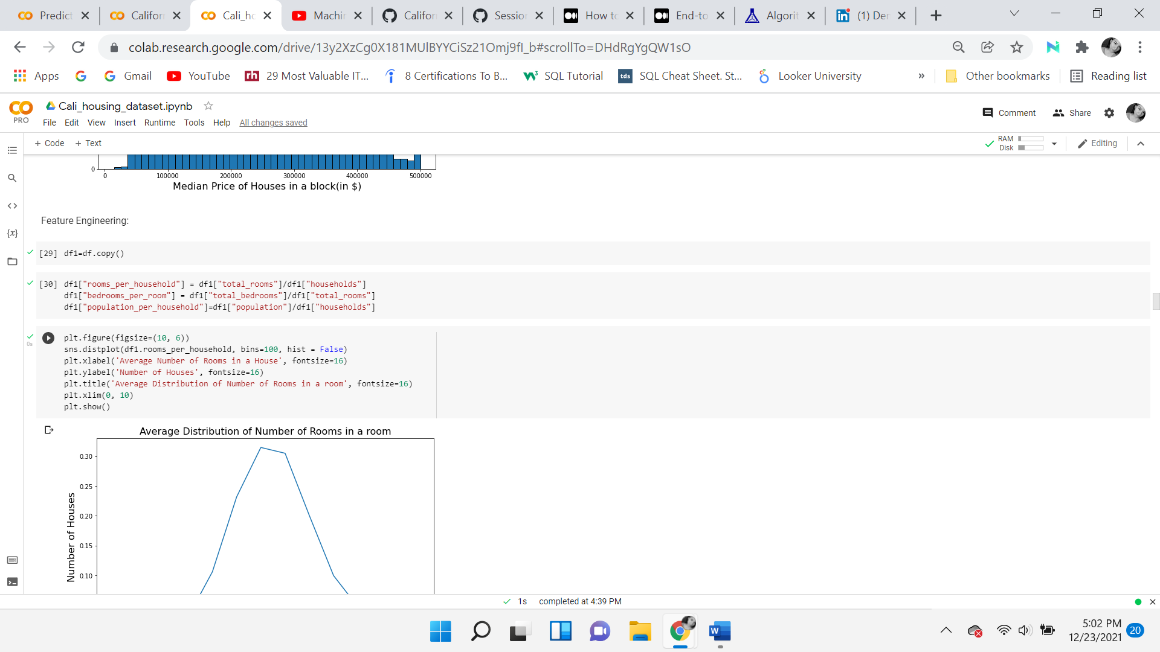

Below a line graph shows that the average number of rooms is 5, which is standard. This seems a lot more normal and reasonable for a household.

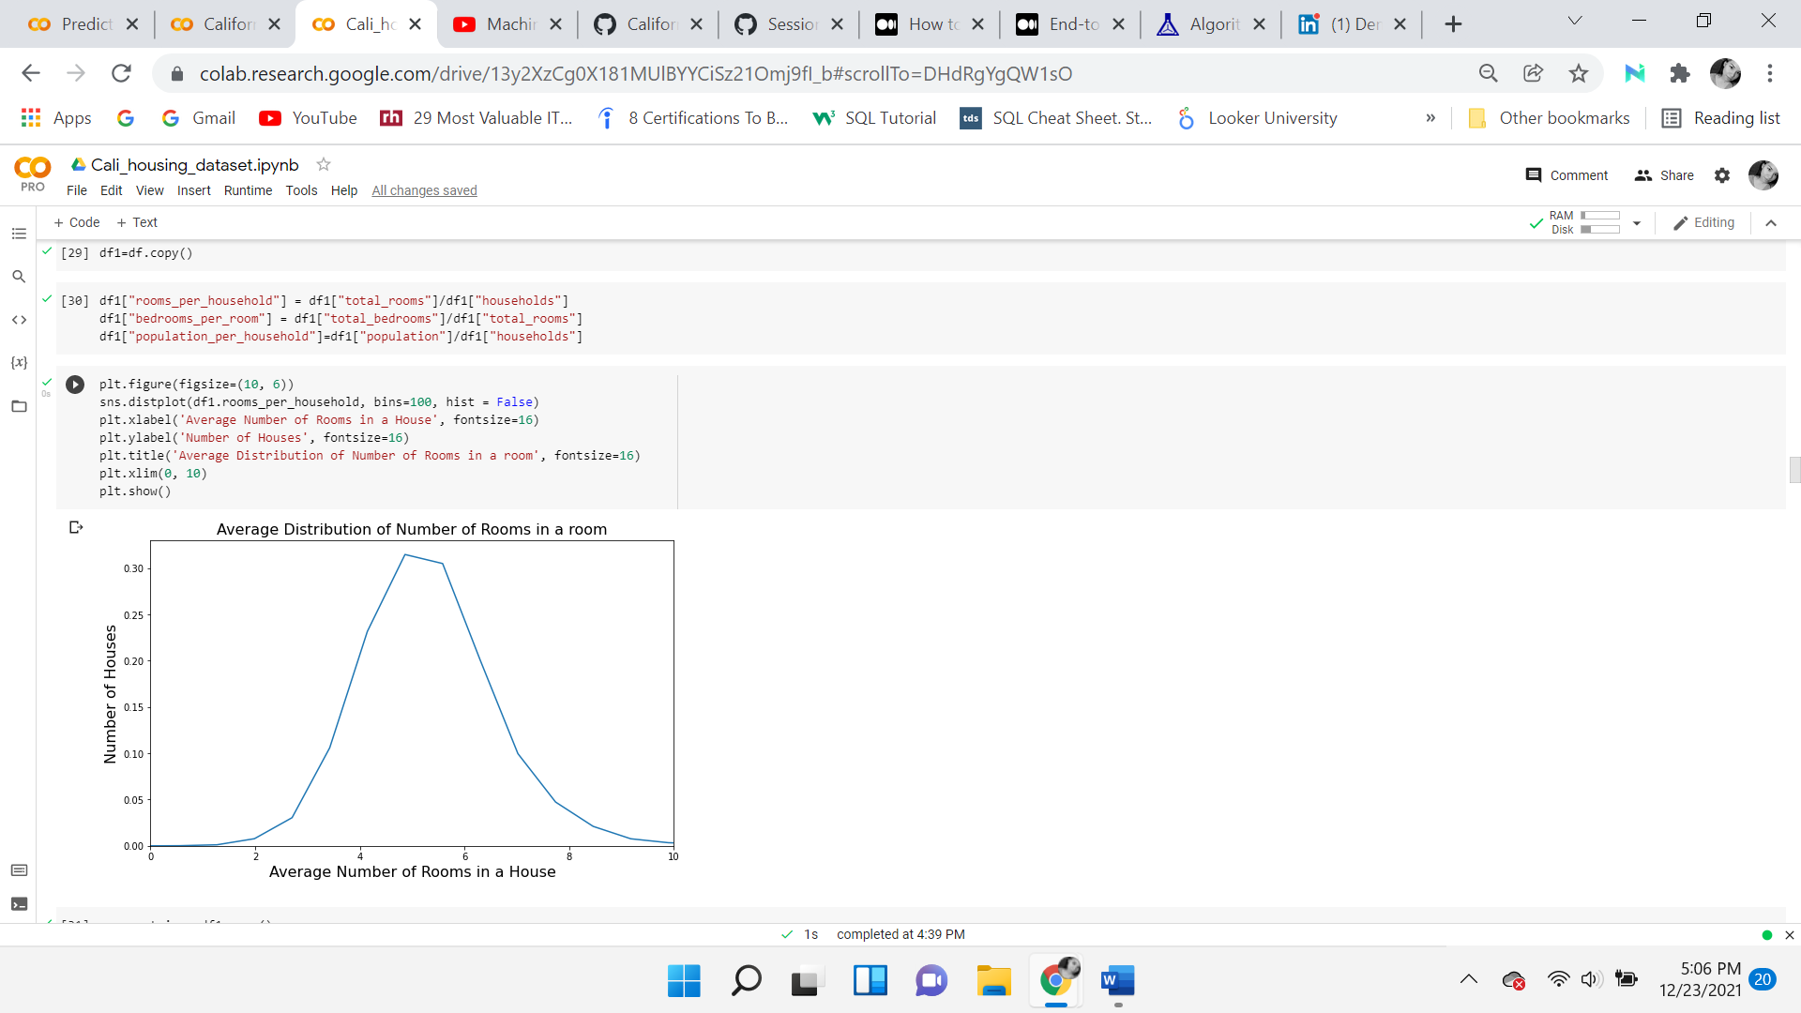

**Correlation Analysis**

A Correlation matrix is performed of the numeric values of the variables compared to the target variable, median house value. A strong negative correlation indicates that as one variable increases, the other decrease and vice versa. There continues to be a strong correlation between median house value and median income, but as far as the rest of the features concerning median house values, none of the variables present anything excessively high. Although two noticeable differences are:

1. Rooms per household are slightly more correlated (0.151948) with median house value than total rooms (0.134153)
2. Bedrooms per room are negatively correlated (-0.220049) than total rooms (0.134153) and total bedrooms (0.049454): homes with a lower bedroom/room ratio are more expensive. It can be inferred that more expensive homes may have more rooms such as play areas, dens, second living room, office, etc.

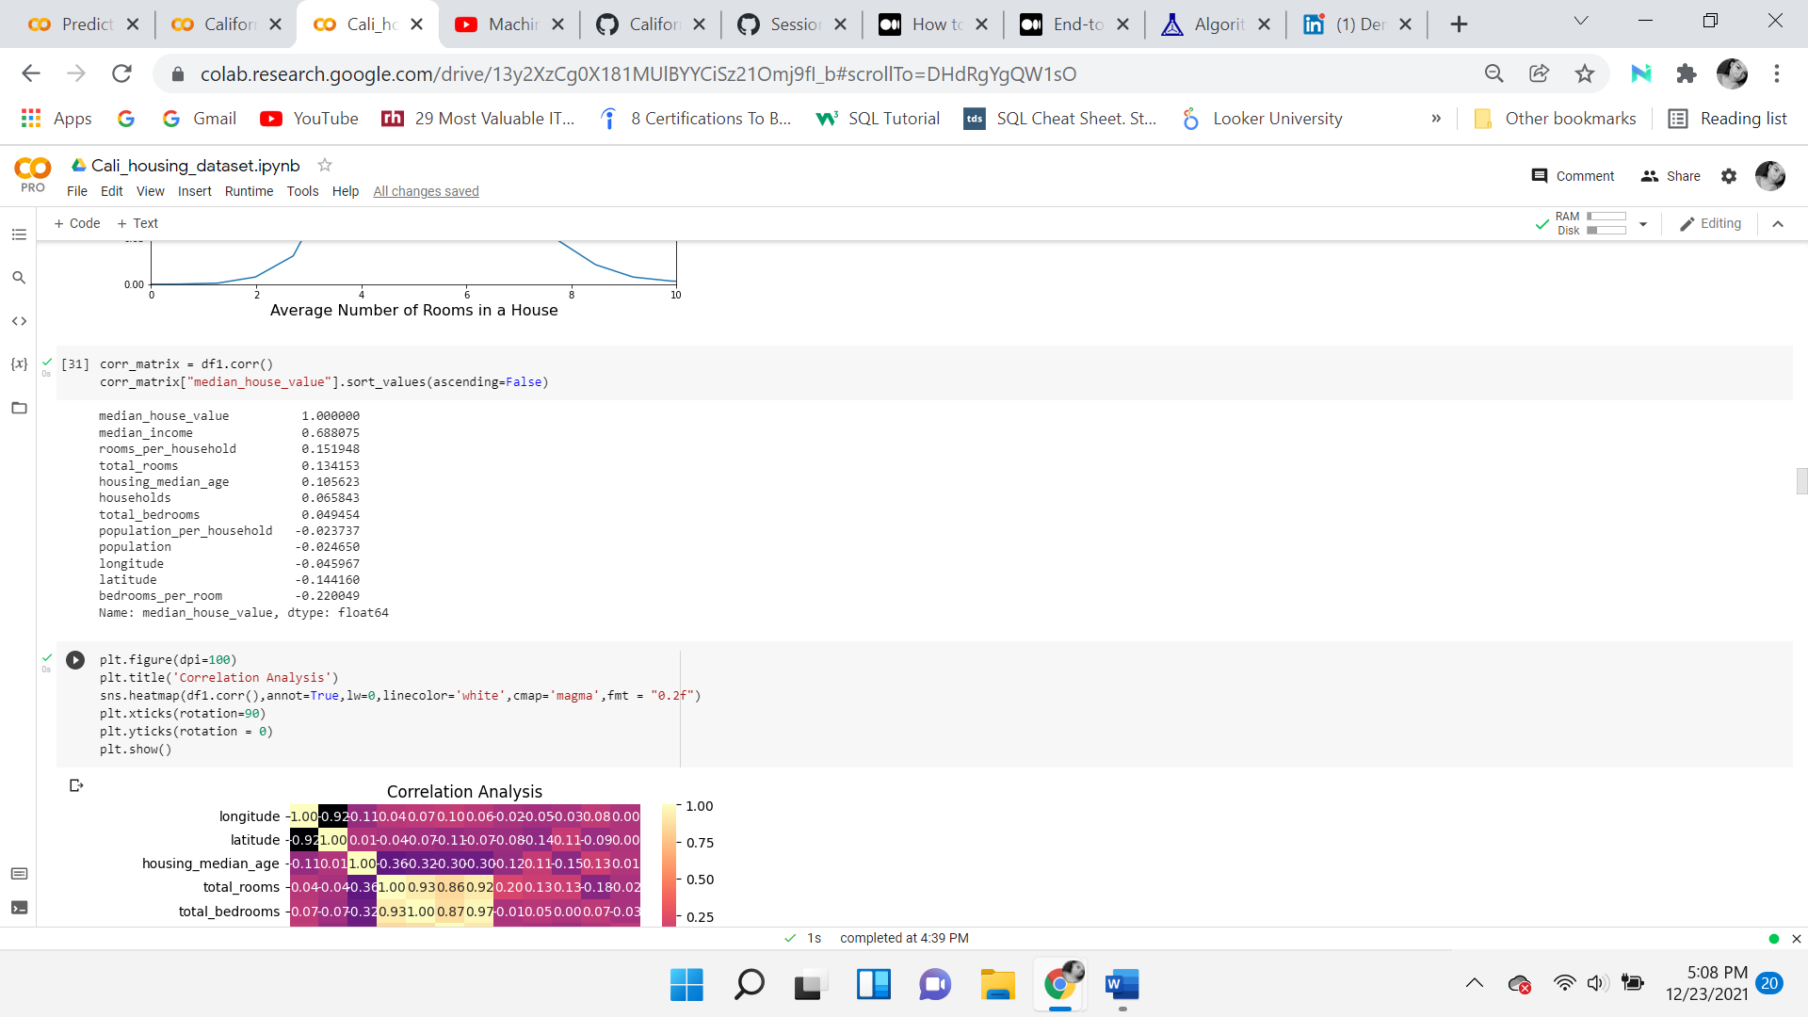

### **Second Correlation Heatmap**

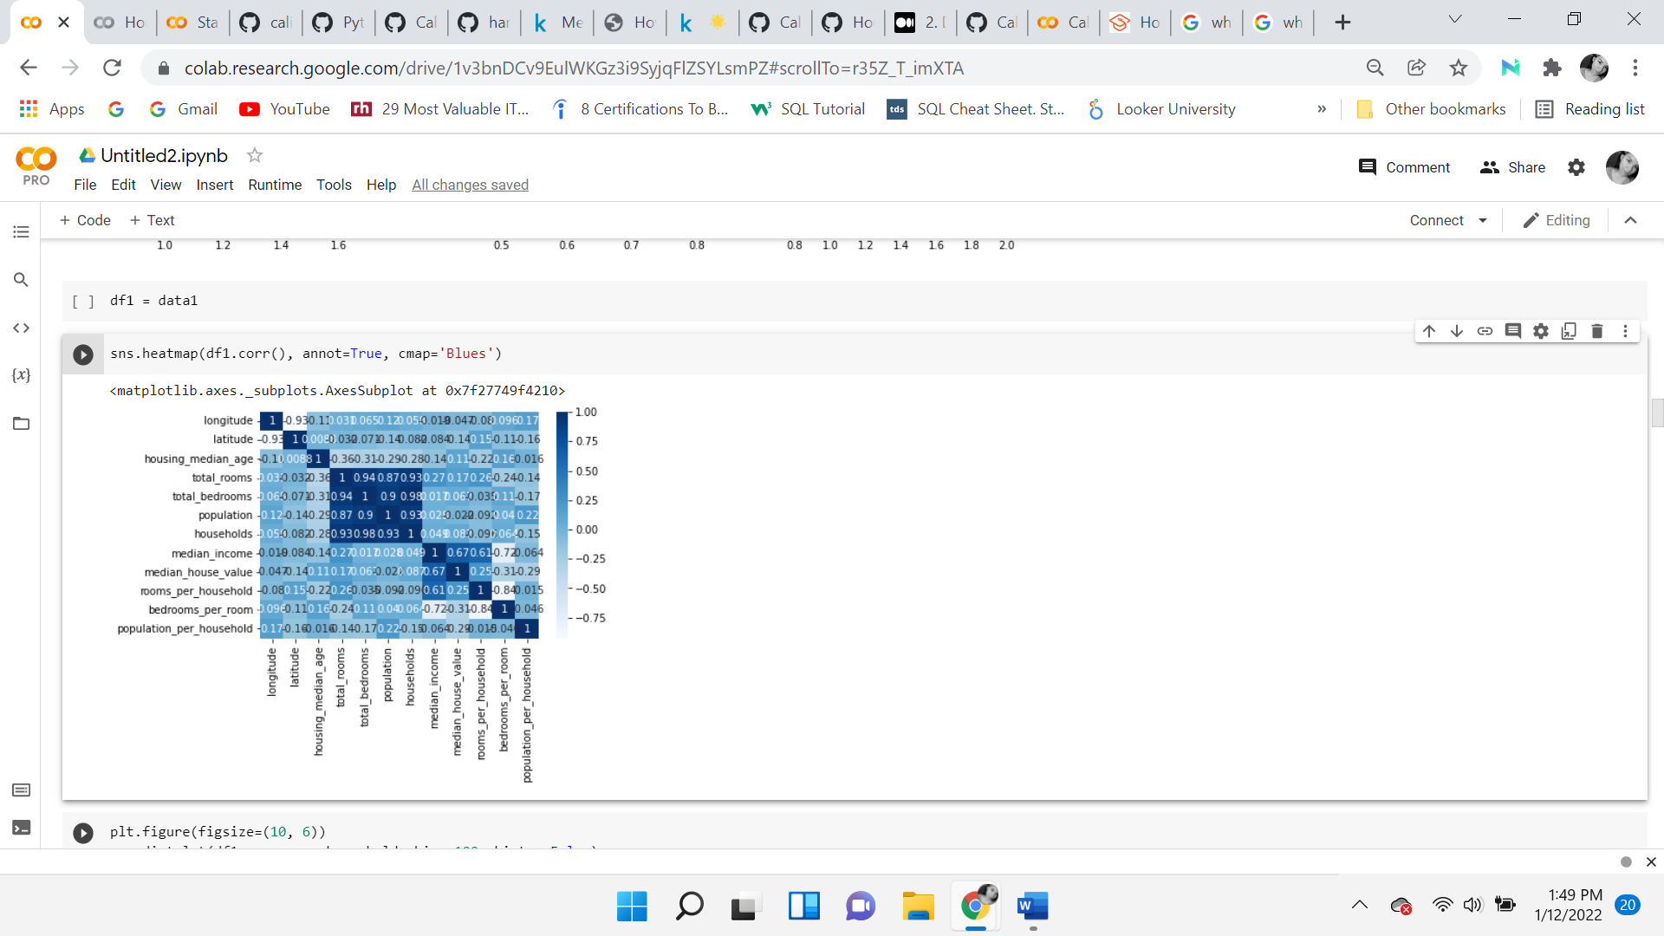A second heatmap is displayed after creating the new variables. It allows for a visual inspection of the correlation relationships within the dataset. Many times, visualization can help see more as they can stand out, which cannot be replaced by simply looking at the correlation coefficients. As seen below, longitude and latitude have a negative correlation, shown in white. All the dark blue, squares marked with 1.00, are relationships of variables with themselves. As stated before, the same four variables continue to show a strong correlation.

***Median home value vs Rooms per household***

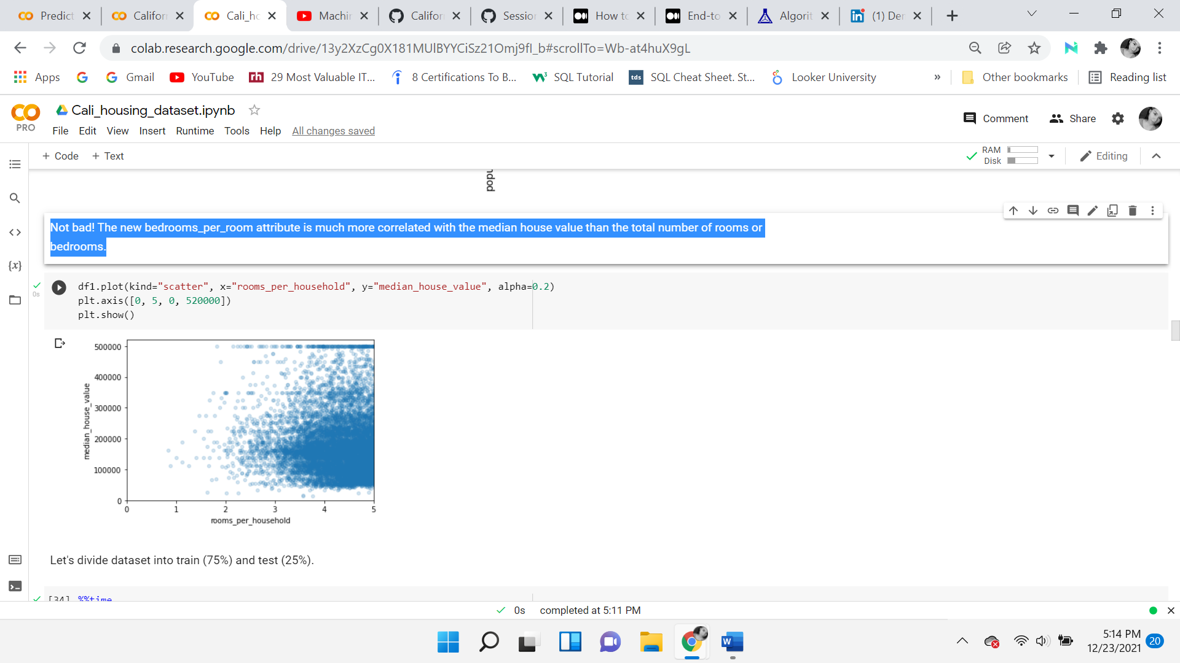

A scatterplot is demonstrated to see the relationship between the median home value and one of the new variables, rooms per household. This makes sense, the more rooms a house has, the more likely it will be more expensive. Trying to make sense of the visualization, being that the average number of rooms in a household is around 5, and the scatterplot is mostly grouped between 4 and 5, the average price for a house with 4-6 rooms, was probably between 100k to 250k, at the time of that census, in 1990.

**Log Transformations**

Transforming the variables improves them by reshaping the distribution to reduce skewness and displays an equal spread. Also, it is convenient because it helps the algorithm better understand the data, with the potential to perform better. BoxCox is a useful technique for transforming data so that it is normalized. Provided by the SciPy stat package, the function takes the non-normal data and outputs the fitted data along with the lambda function which was used to fit the original data values. Then it provides a more normalized distribution. Below a Class function is created, which acts as a blueprint for making different objects in python. Inside the class object, a defined function is used to perform the box cox on the independent variables stated in the python code. The histograms present a more normalized display of the independent variables.



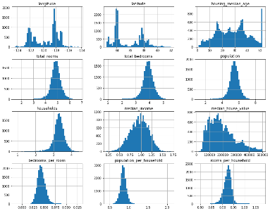

**Transform the Target**

As previously observed, the target variable, median house values does not have a normal distribution. At the maximum cap value of 500k, there is a clear outlier. It is rightly skewed and shows a heavy tail. To normalize this variable, a log transformation is performed. The image on the left is before the transformation and the one on the right is after.

A probability plot is a graphical representation that helps identify if data follows a normal distribution. In the graph before the transformation, the blue dotted line begins off of the red line, in the center stays on the red line but then peaks up at 500k and stays flat. After the transformation, the blue dotted line begins off the red line, then follows it, and again stays flat at 500k. This time, the variable is transformed into a left-skewed distribution, this happened because when normalizing the data, the 500k value was accounted for, which was different from the rest of the data, causing a significant shift. To address this problem, the maximum value, which is also where the data is capped, the outlier is removed.

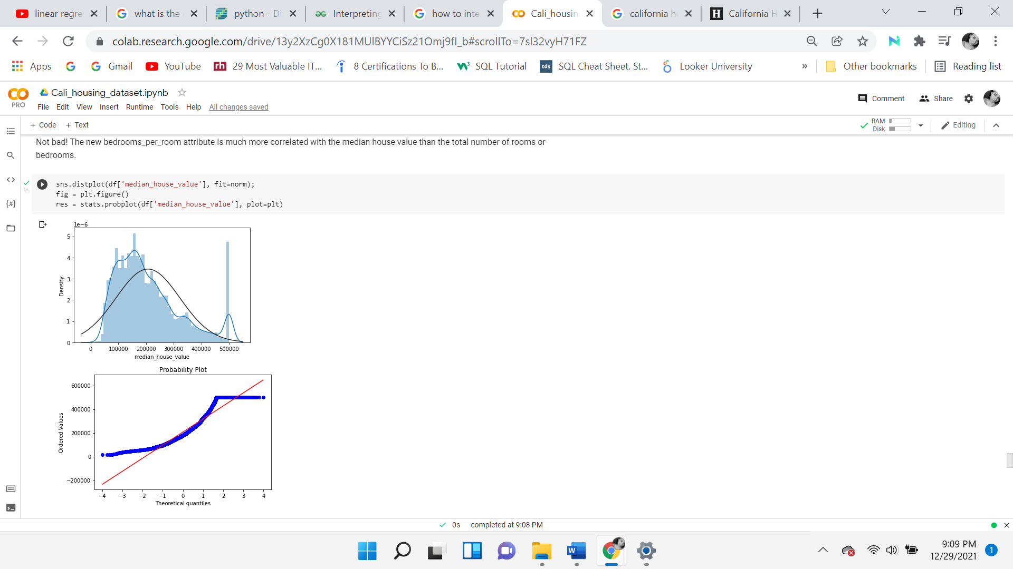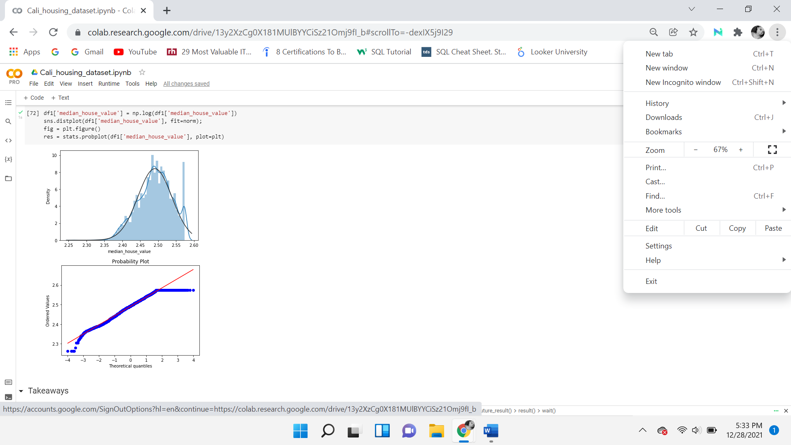

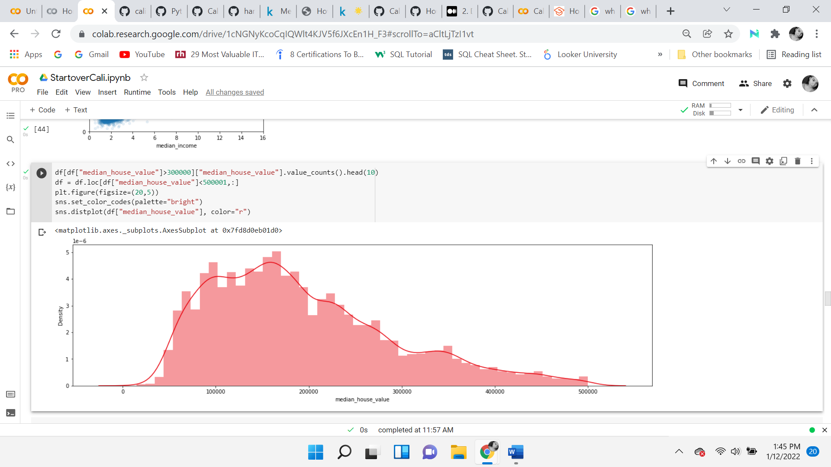

**Stratify the Median Income**

For the median income variable, stratified sampling is used to maintain the portions of the original dataset. The median income is considered an important feature that will help predict the home prices, therefore misrepresenting or changing too much of the data, will not produce an accurate prediction. Representing the overall population is key.

First, the median income variable is divided into 5 portions known as binning. The bins are limited to 5 homogeneous subgroups called strata. It’s important to have the right number of instances for each stratum. There should not be too many strata and each stratum should be neither too large nor too small. Stratified sampling can help reduce or eliminate bias from the model.

As illustrated below (purple bar graph) there are 5 clusters, represented in tens of thousands of dollars. The mathematical form of rounding, ceilis used to round up to the nearest discrete value. This technique will normalize the data and increase accuracy when fed to the machine learning model. Otherwise, the model could be biased and inaccurate.

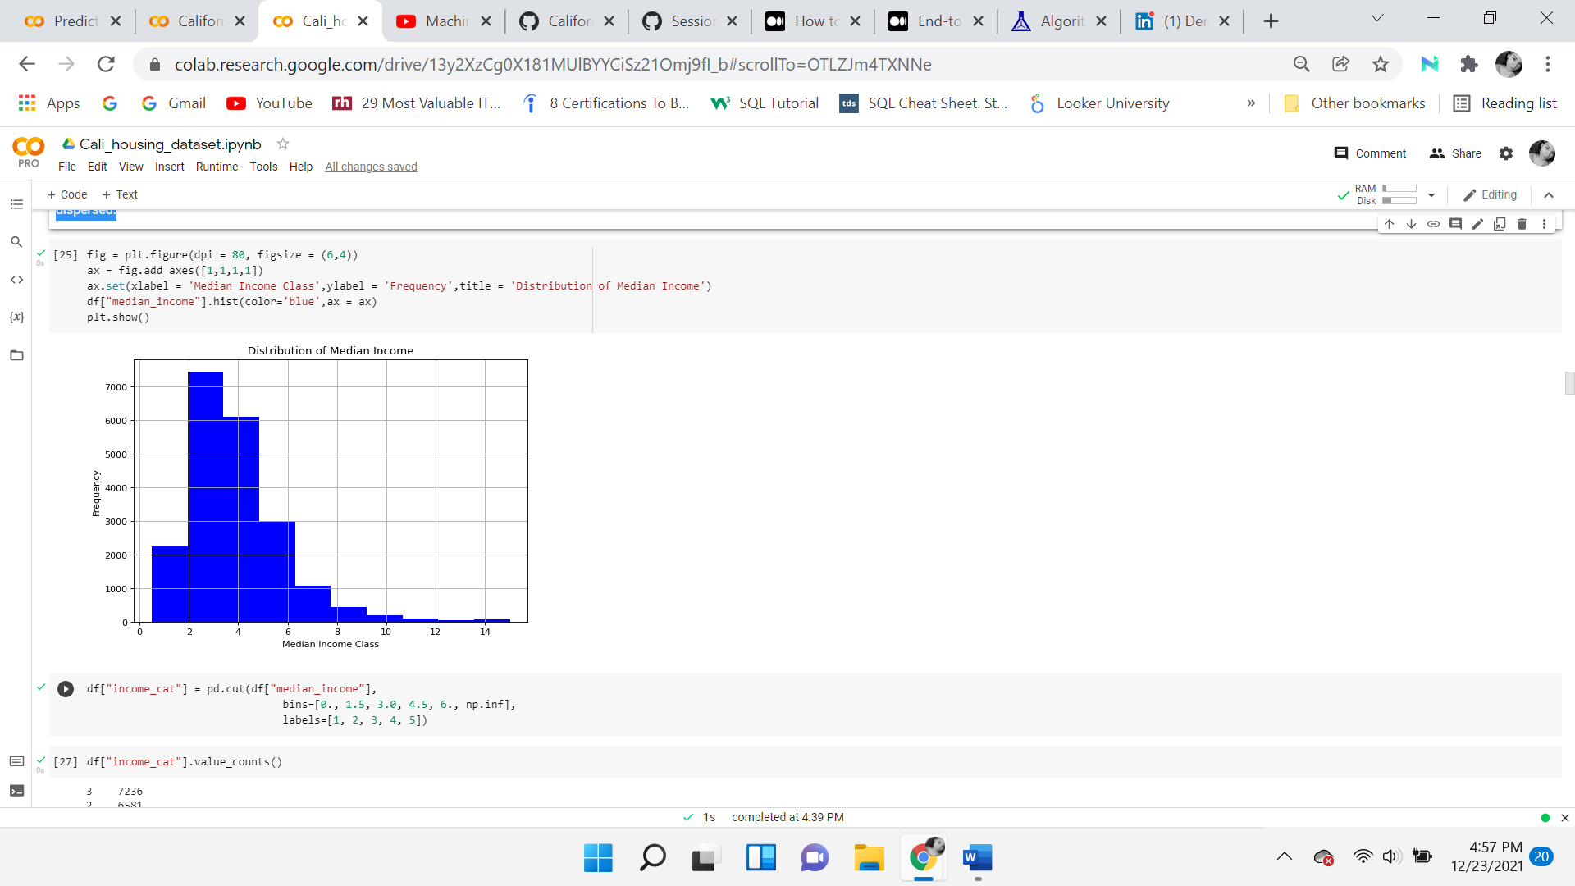

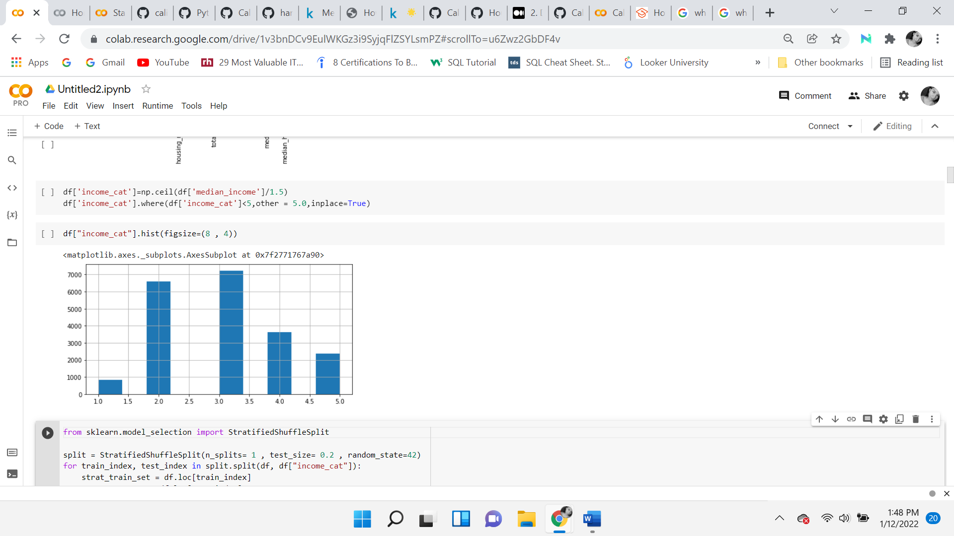

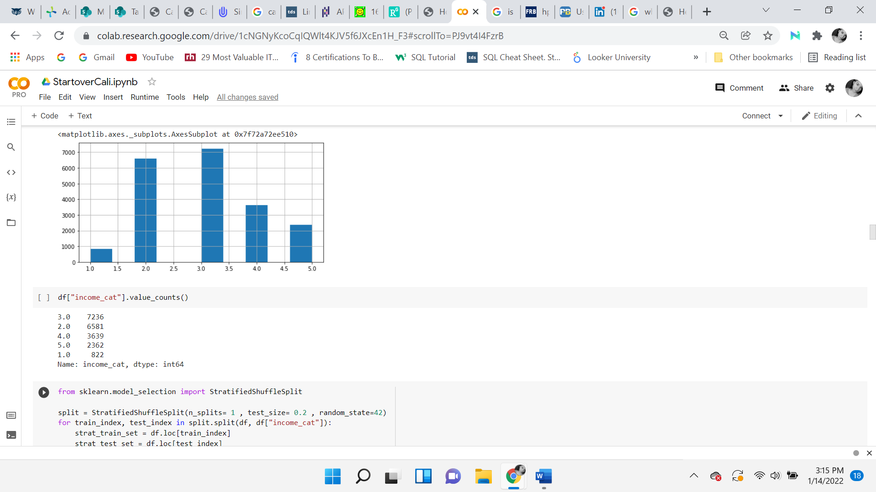

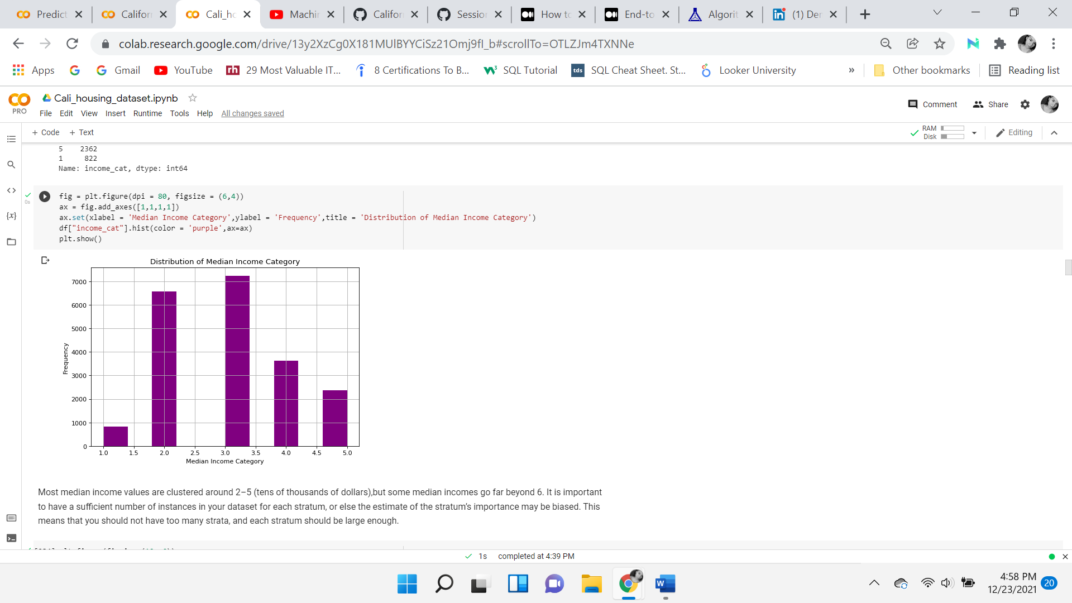

# 

## ***Normalization and Standardization***

## Normalization is the process of rescaling the data so that they have the same scale. It’s used when the attributes in the data have varying scales. Standardization (z-score normalization) is when the features are rescaled, so the variables have properties of a standard normal distribution. In a standard normal distribution, the mean is equal to zero and the alpha, which is the standard deviation from the mean is equal to 1. Normalizing and scandalizing the data is important so that they are evaluated on the same scale. Otherwise, the model will consider variables significant, which probably are not as significant. Scaling and removing outliers are recommended before performing PCA as this technique is sensitive to outliers and could potentially give an inaccurate output.

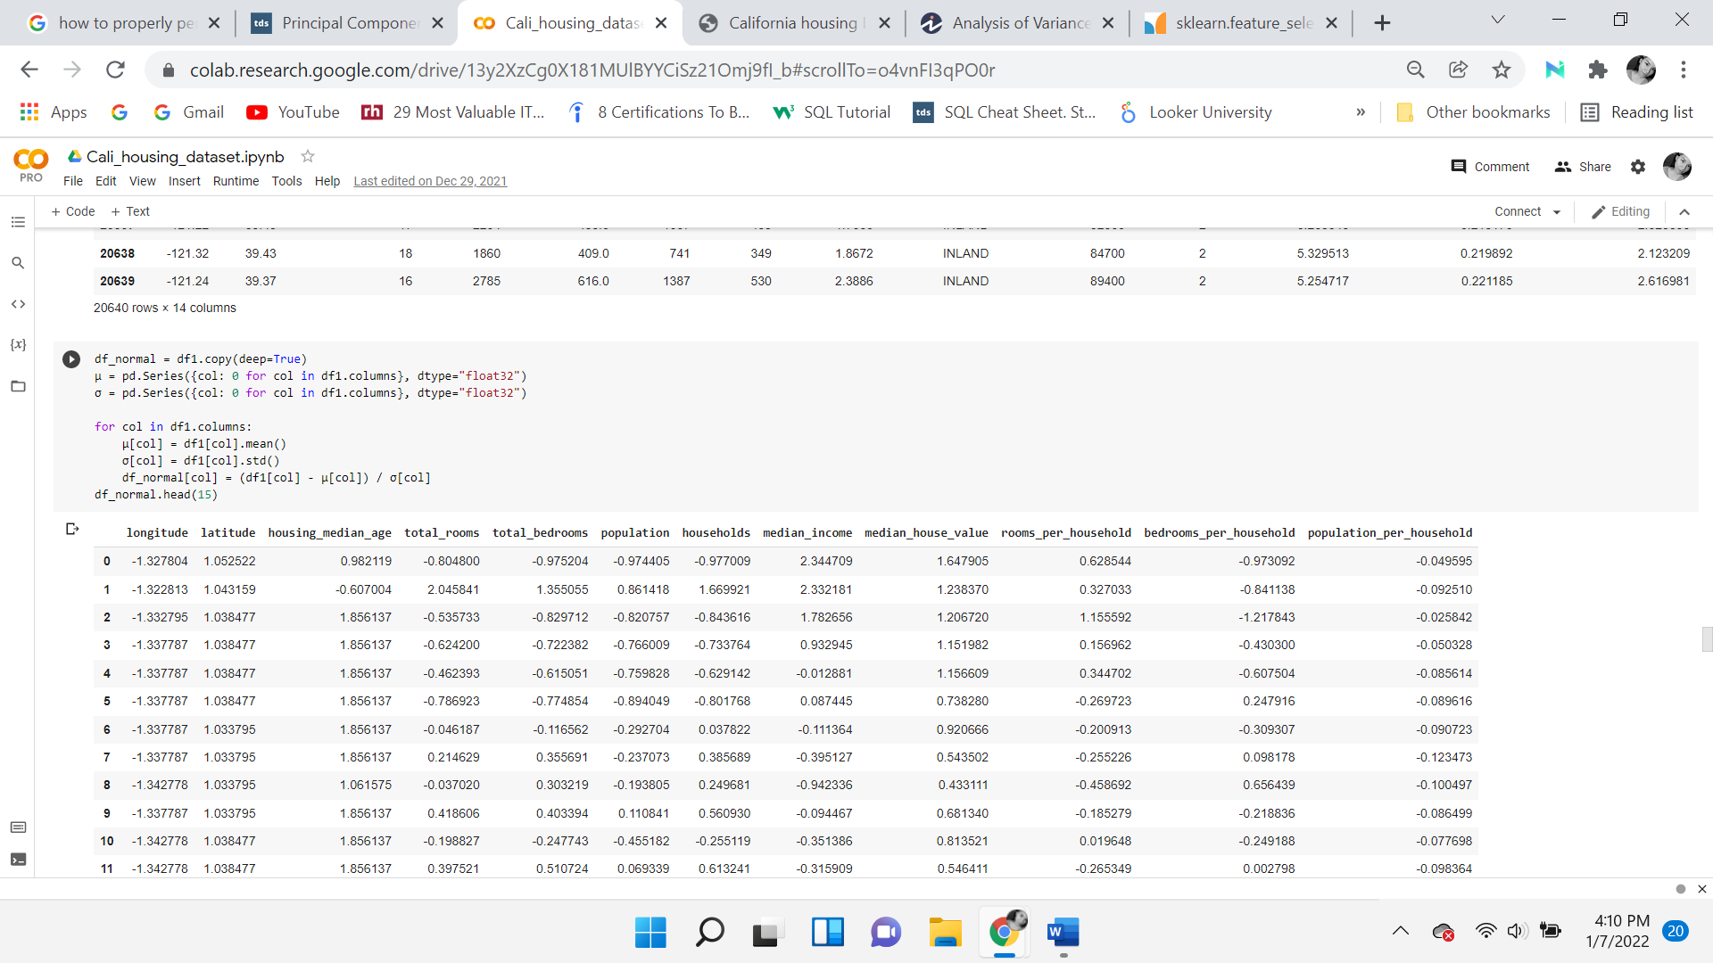

## Feature selection is choosing those features which are required to explain the predictive power of a statistical model and dropping out irrelevant features. There are various methods for feature selection. It can either be done by filtering out less useful features, known as feature reduction, or by combining features to make a new one. When reducing or combining features, it's important to ensure not to lose a lot of information.

**Data Reduction**

The data reduction phase consists of performing Principal Component Analysis and Inflation Variance Factor to identify the most useful and important features. Both these techniques are similar but work in different ways. Both were used to see which output they provided. An advantage of these data reduction techniques is that they can eliminate highly correlated values, reduce overfitting, which can improve the performance and accuracy of the algorithm. A disadvantage is that valuable information could potentially be lost.

**Principal Component Analysis**

PCA is a technique used for dimensionality reduction, to ensure the most important features are used. The method works best with linearly based data because the approach used consists of accounting for total variance in the data and transforming the original variables into a smaller set of linear combinations. It creates new axes coordinates and has the most variance, by calculating the eigenvalues of the covariance matrix and leaving the eigenvectors with the most variance.

F-test and mutual information are univariate statistical tests for regression models. Both are fed into the *SelectKBest* as a scoring function. The f_regression function is a quick linear model that tests the effects of a single regressor, again the target variable median home value. First checks if the variables are cross-correlated then it returns the f score followed by the P-value. The K is equal to 5, which returns the top five variables. Mutual information measures the mutual dependency of two random variables. It will equal zero if two random variables are independent of each other. It calculates the amount of information from one variable by observing the other.

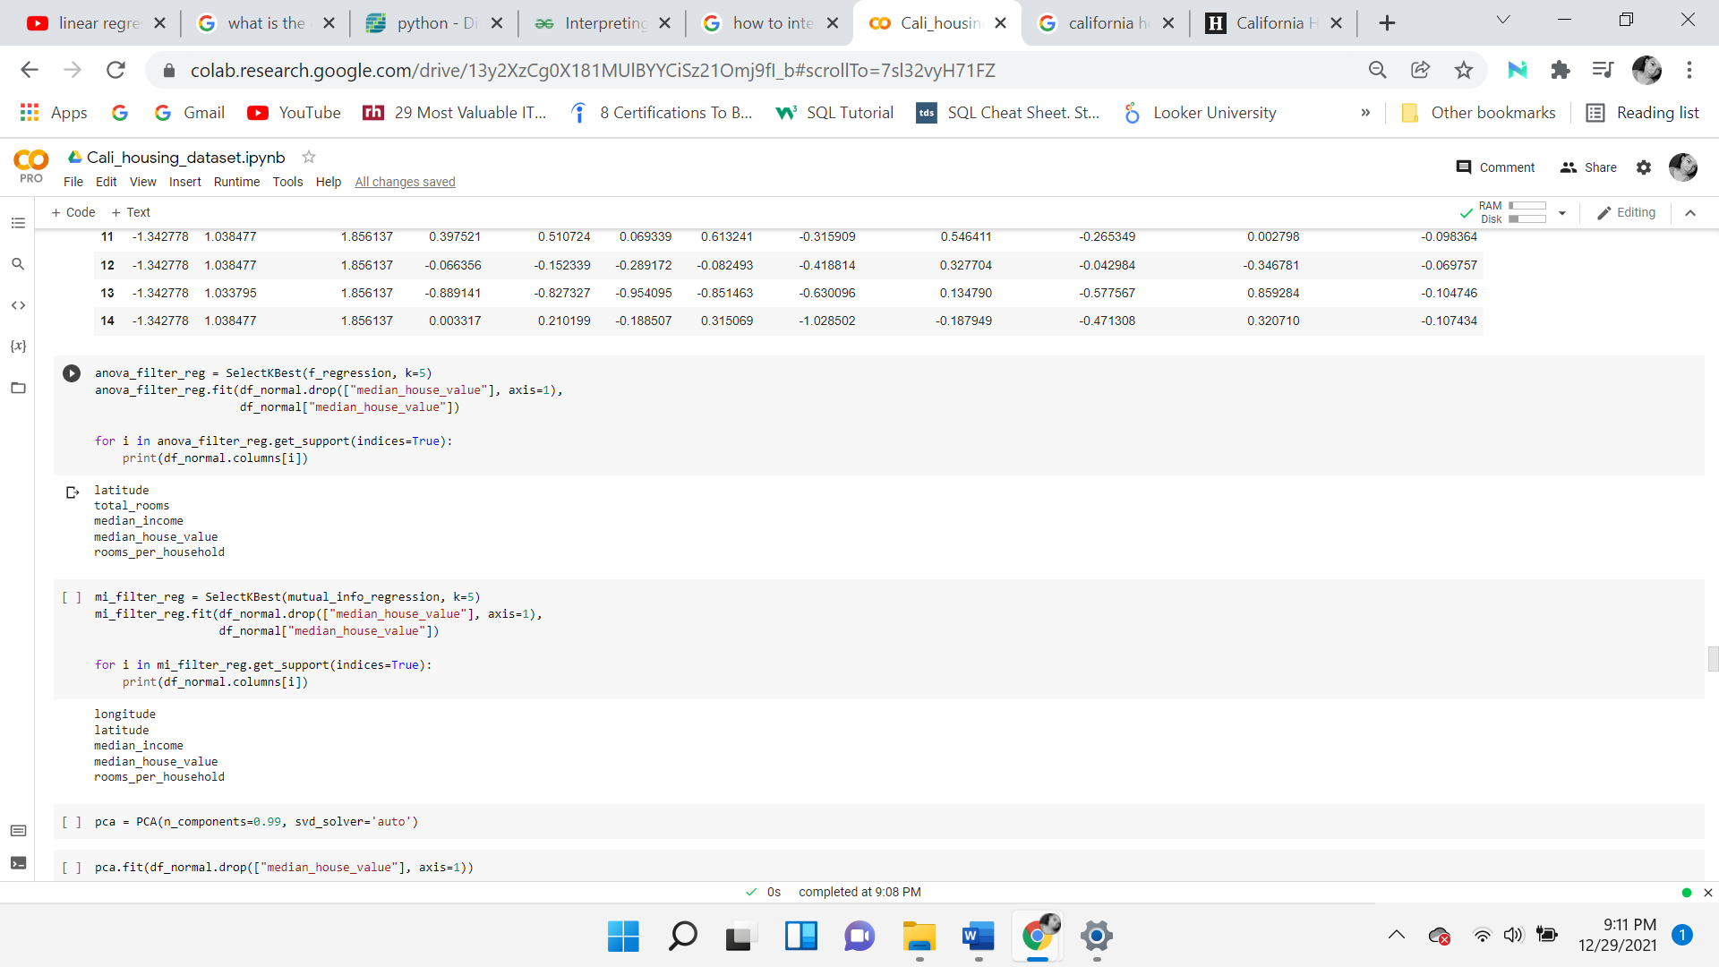

According to the F-test, the important variables are latitude, total rooms, median income, median house value, and rooms per household. This is in line with the original correlation matrix. For mutual information, the important features are almost the same, with four out of five being the same. The two outputs differ in total rooms and longitude. Mutual information is known for being susceptible to non-linear relations while f regression is not.

**Variance Inflation Factor**

A method used to examine multicollinearity is the variance inflation factor. It measures how much a specific variable contributes to the standard error in the regression model. If there is significant multicollinearity, the VIF will be large for the variables. A VIF value of 5 or greater is usually recommended to be removed from the model. Below is displayed the VIF before and after the significant variables are removed. The variables removed were total rooms, total bedrooms, and households. These particular variables were used to create new features and so the information is considered duplicate if they are not removed. The overall output variance is significantly reduced when these features were dropped.

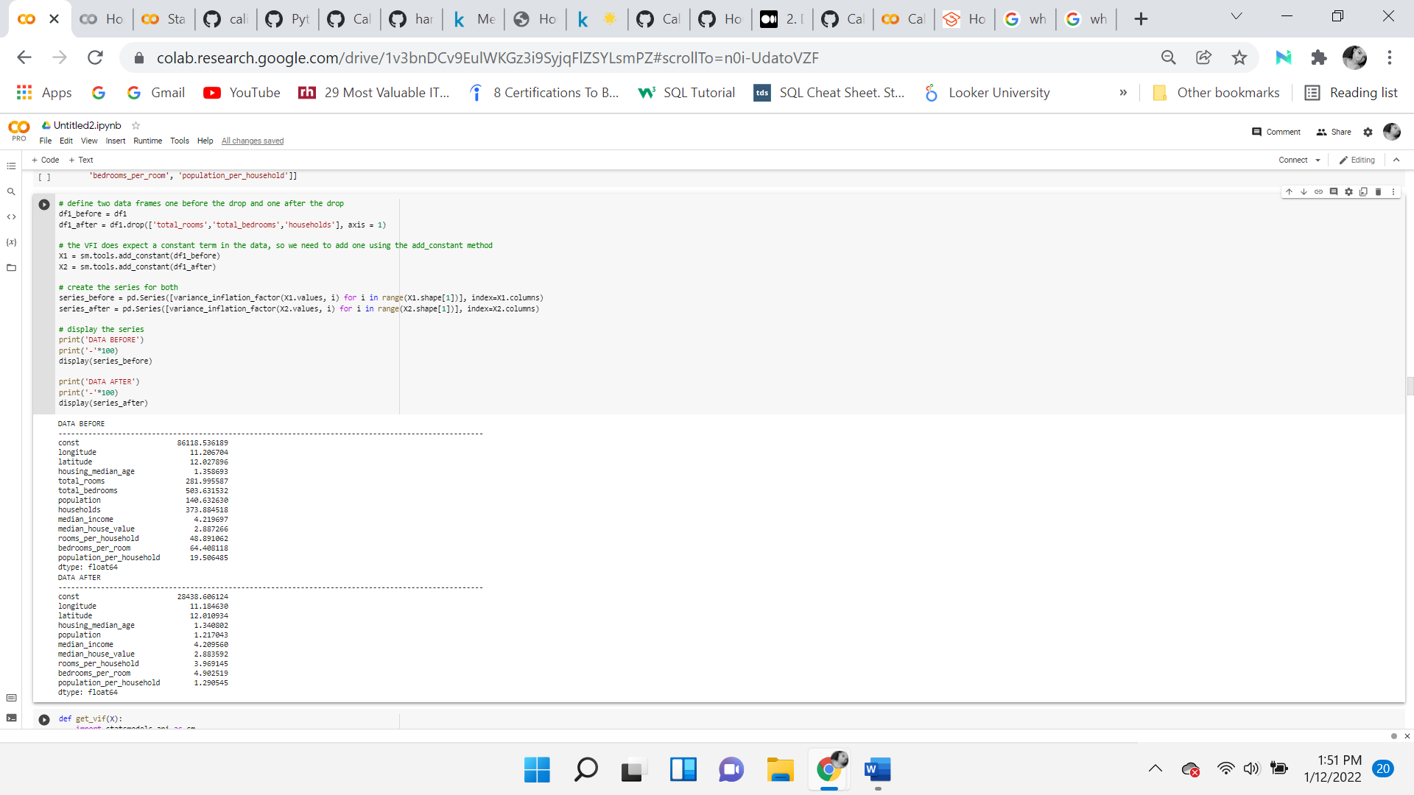

**One-Hot encoding**

To perform the machine learning algorithms, all the variables need to be numeric. Therefore, it’s necessary to convert the ocean proximity variable to binary data. This is done by creating five new variables and one-hot encoding each category. After the conversion, the old ocean proximity variable is dropped, and to ensure that the changes happened, it is displayed below. All the numeric variables are stored in a new data frame, called df_house. The output is known as a **scipy sparse matrix**. It saves a lot of memory and is convenient when there are categorical features with thousands of categories. It only stores the location of non-zero elements and stores a matrix full of zeros except for one per row. The ocean proximity is displayed with a 1 if the row is that row, and 0 otherwise. For example, if row 4712 is <1H OCEAN then it will have a 1 and every other column will be a 0.

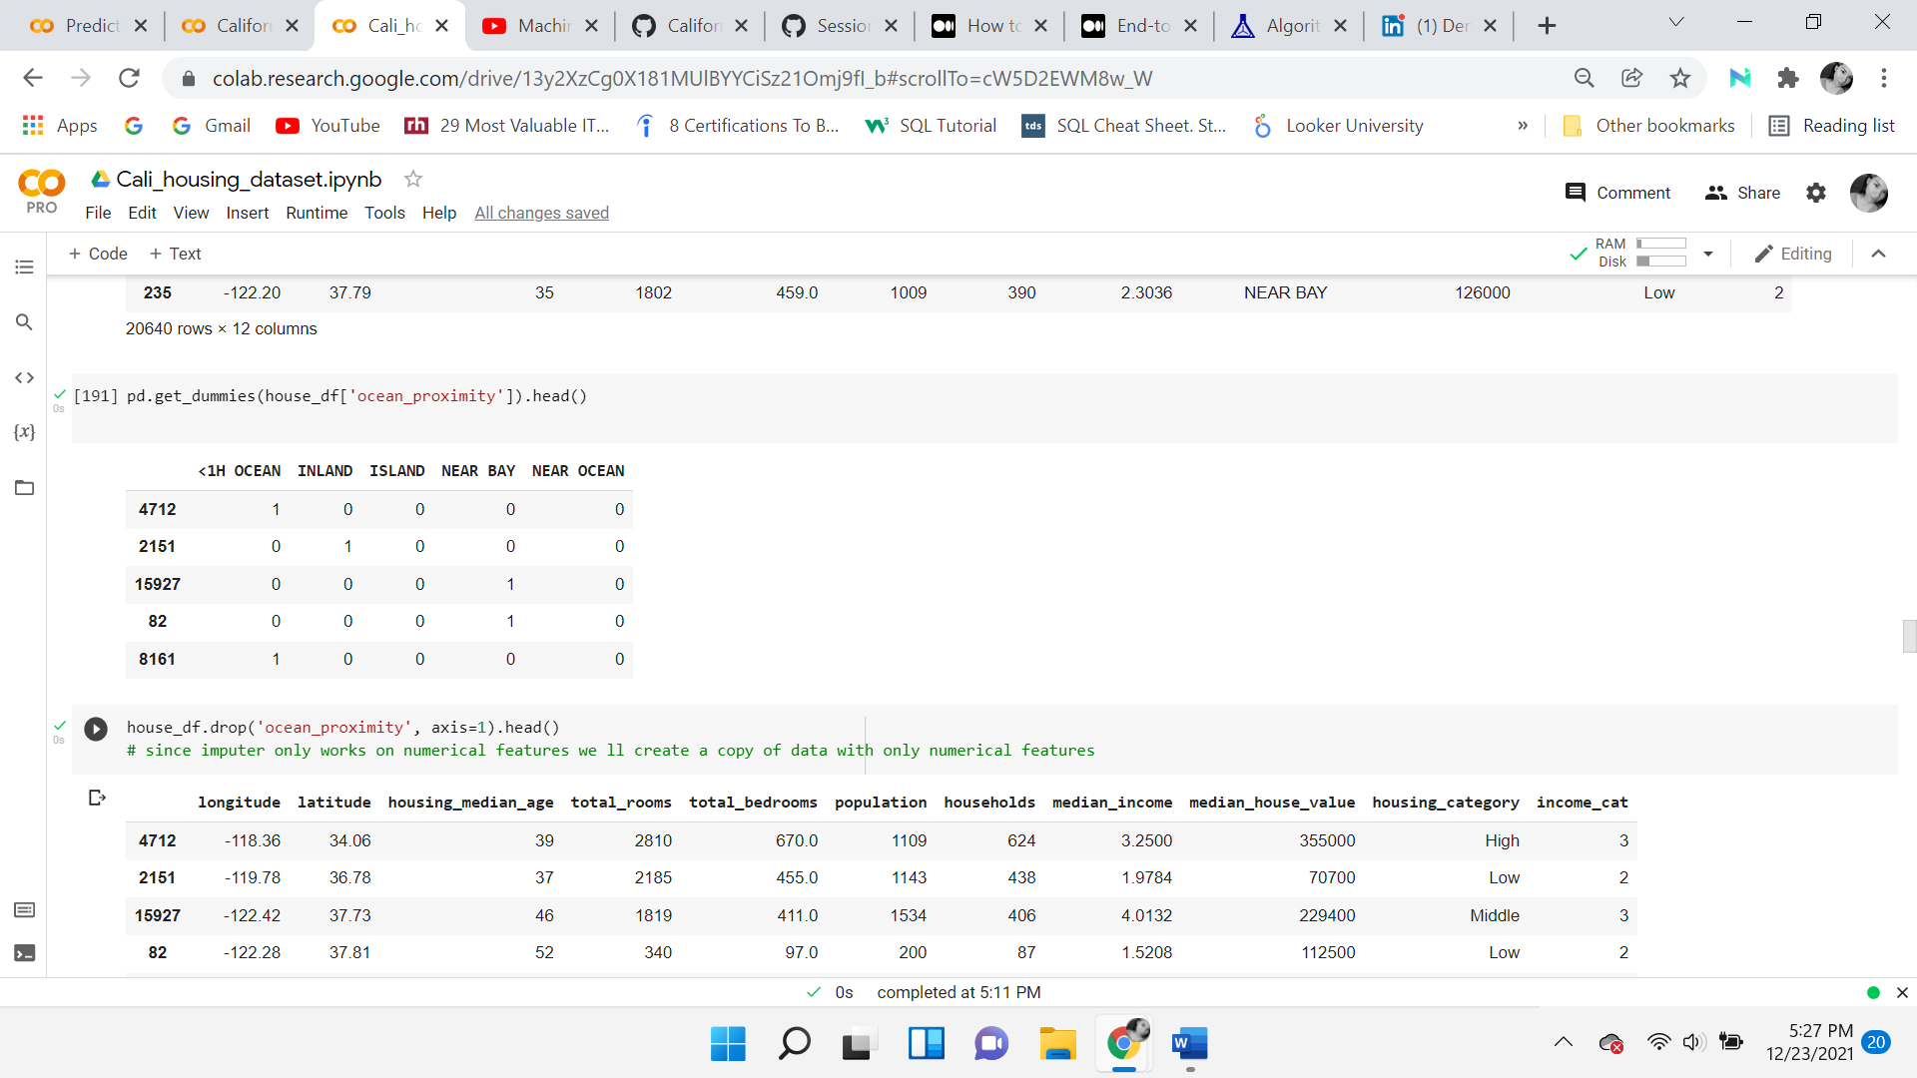

After converting the ocean proximity variables, ensure all are numeric columns, dropping the columns that were converted.

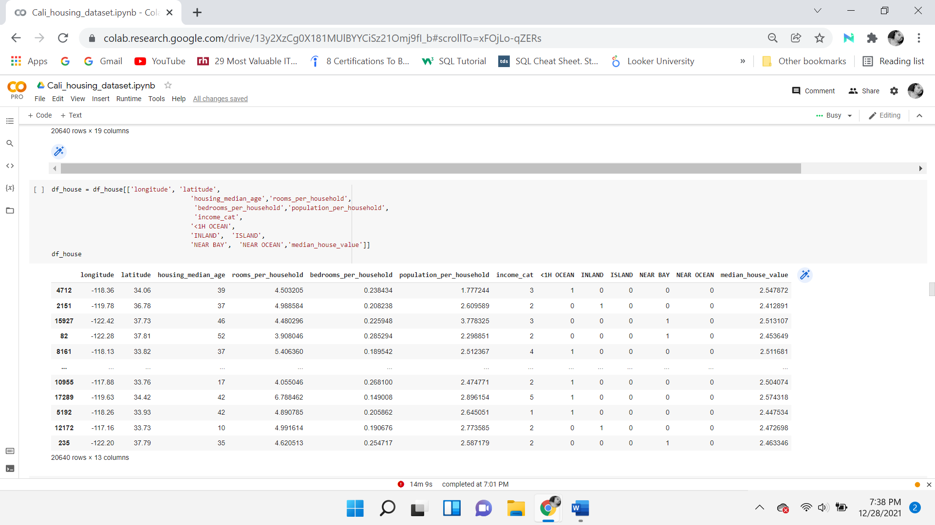

**Train, Test, and Validation Split**

The data is split into a train, test, and validation sets. This will allow for performing different calculations on the three different sets to evaluate how the model is performing. With the training set consisting of about 80% of the data and the test and validation sets making up 20% of the data, each set 10%.

The preprocessor is scaling the data. A custom function was created to set all the rows equal to the scaler. Scaling the everything but the ocean proximity and income cat variables being that they were previously converted. Standardizing the values is necessary to allow the model to evaluate each variable on the same scale.

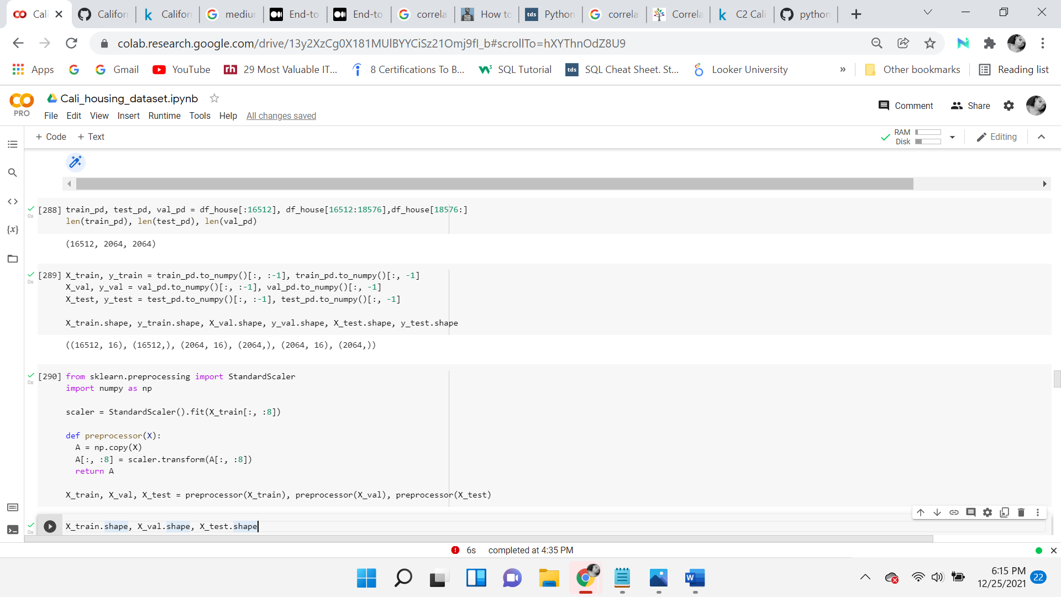

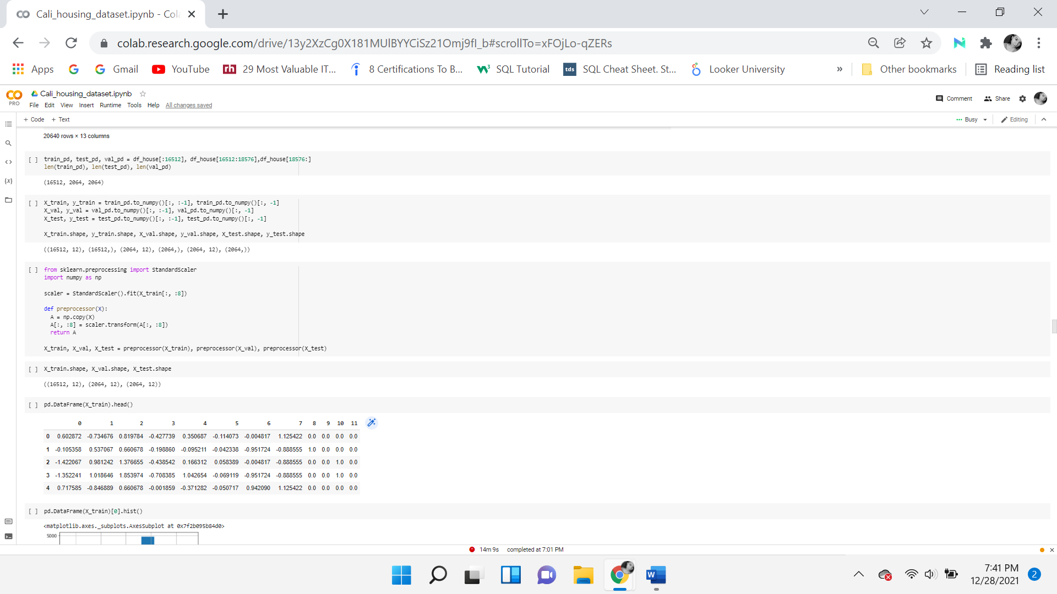

**Analysis**

***Hypothesis Testing***

The *statsmodels* module was used to implement the Ordinary Least Squares method of linear regression. This technique was chosen because is convenient and helpful in that it calculates all the necessary metrics. Ordinary Least Squares is performed on the target variable against median income, to establish a relationship between the target and explanatory variable. This is done to evaluate the hypothesis test and the p-value. It’s essential to create a constant variable and then fit the model. The goal of the OLS model is to the minimum the mean squared error. An advantage is that the metrics are calculated for you. The disadvantage is that you need to interpret it.

**The Hypothesis**

* ***Null hypothesis:*** There is no significant relationship between the median home value and median income.
* ***Alternate Hypothesis:*** There is a significant relationship between the median home value and median income.

***OLS Results***

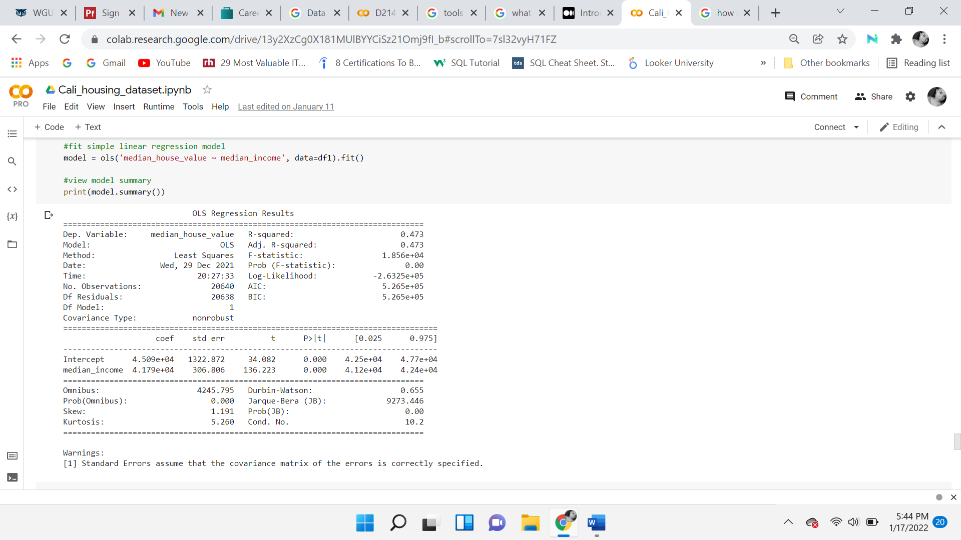

***Significance***

The hypothesis test begins with a gradient of zero (i.e., there is no relationship) Use a sample to see if there is enough evidence to reject this null hypothesis. If far enough away from 0, we can reject. Which infers that there the variable is significant. In conclusion, we reject the null hypothesis.

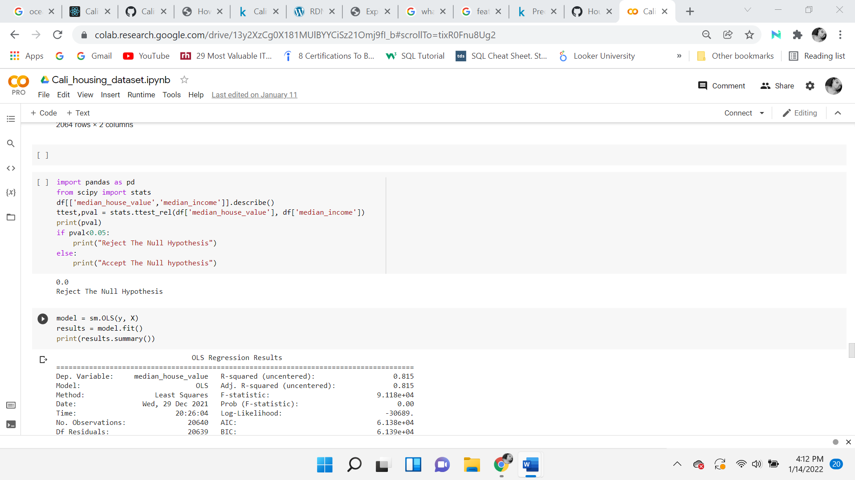

**Machine Learning Algorithms**

The study will use a variety of machine learning techniques to analyze the significance of the response variable against the explanatory variables and identify which variables can produce the best results. As the article *Housing Price Prediction Based on Multiple Linear Regression* states, “Housing price is aﬀected by multiple factors and features of a speciﬁc house” (Zhang, pg. 9, 2021)

The performance of the model will be evaluated in different ways, either through cross-validation, mean squared error, root mean squared error or the coefficient of determination. Cross-Validation is an effective way to evaluate a model. It’s a way of getting an estimate of the Root mean squared error by holding out different test sets and then taking the average of those sets. The K-fold technique is used by default and is randomly split into k equal parts, in this case, 5 equal parts. The cross-validation process is repeated 5 times. The average of all the trial root mean squared error and mean squared error for all k samples of the model will be calculated. The MSE measures how much the average model predictions vary from the correct values. The number is higher when the model is performing “bad” on the training data. The root means squared error (RMSE), is a measure of the difference between the values predicted and the values observed. In a linear model, it’s the standard deviation of the residuals, as well as a measure of how far from the regression line the data points are. The higher the value, the further the points and the less accurate the model is. Each analysis technique was selected to evaluate its performance and compare it against the other techniques.

The ML Algorithms used are as follows:

1. Linear Regression
2. Ridge Regression
3. Support Machine Learning
4. Decision Tree Regression
5. Random Forest Regression (Ensemble Learning)
6. Lasso Regression
7. K Nearest Neighbor
8. Gradient Boost Regression

**Linear Regression**

Linear Regression is a simple statistical model that aims at finding a linear relationship between the dependent variable and the independent variable(s). In this case, it would be considered a multiple linear regression model because it’s working with more than two variables, multiple independent variables. Linear Regression fits a model to minimize the residual sum of squares between the observed and predicted targets. An advantage of MLR is that the model could determine the influence of one or more predictor variables and establish a linear relationship. This model was chosen to determine if there is a linear relationship between the target and explanatory variables. A disadvantage is that when using data that is not linearity based then the conclusion could be inaccurate or misleading.

This algorithm has assumptions, which are:

1. A linear relationship
2. Multivariate normality
3. There is little to no multicollinearity
4. There is little to no autocorrelation
5. The data is homoscedastic

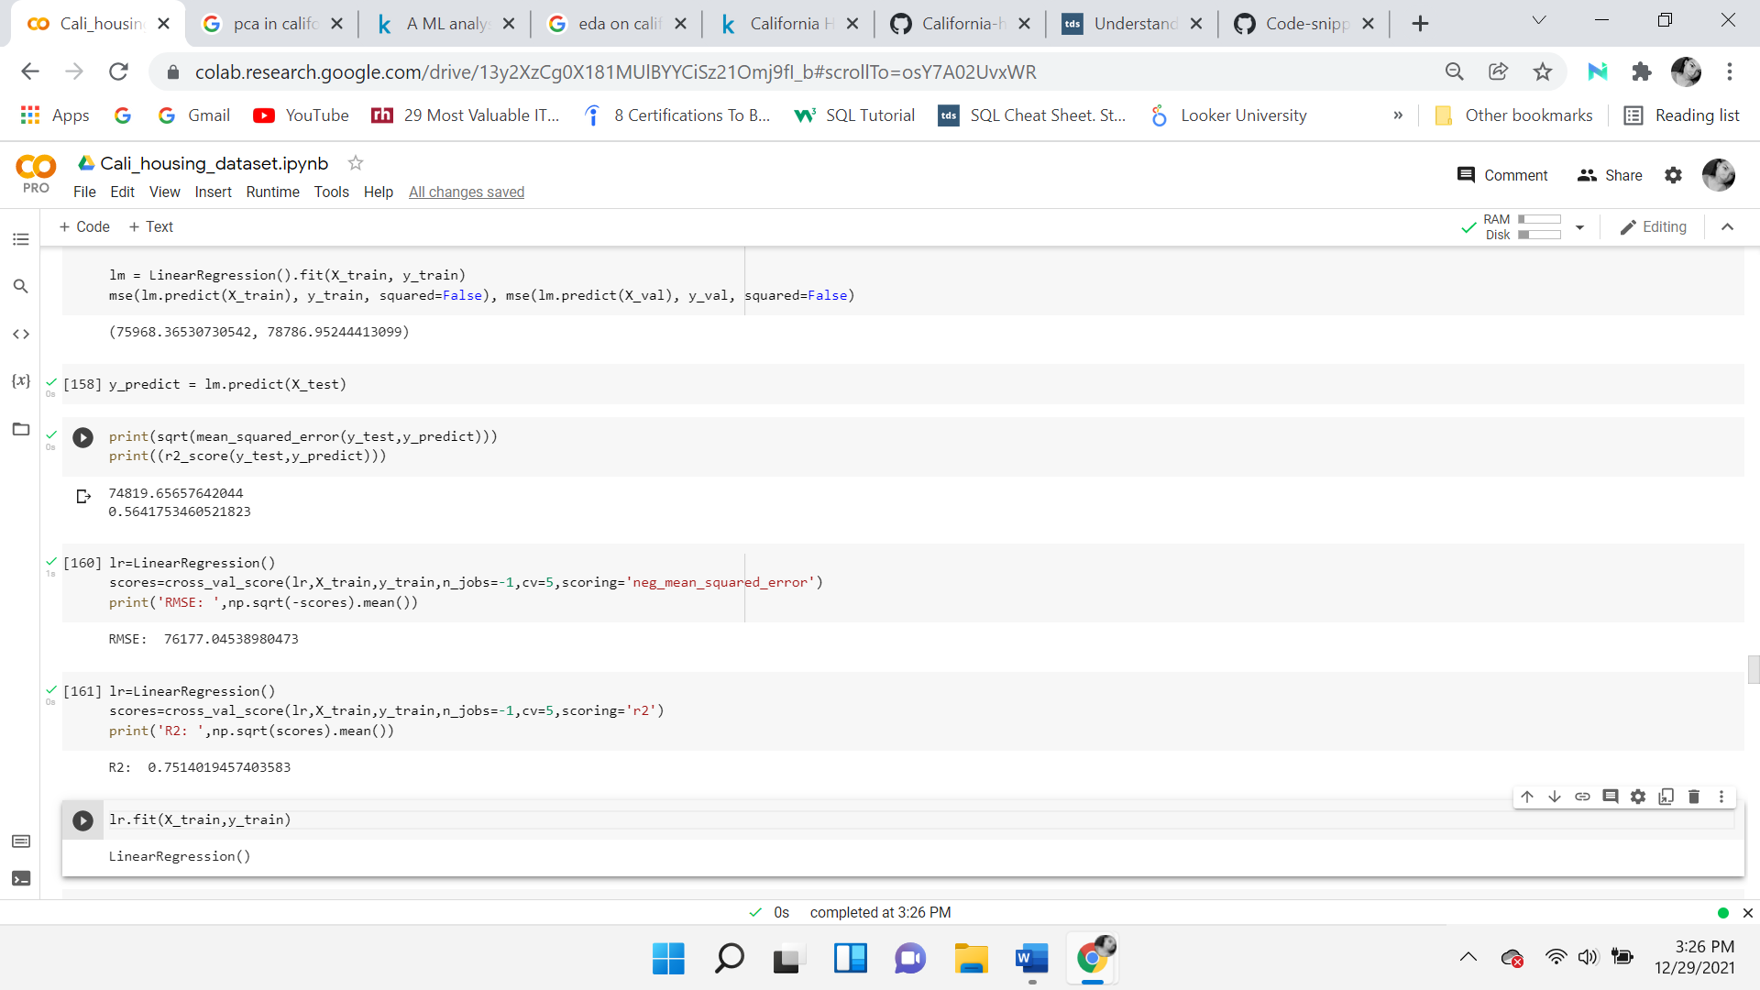

The first two numeric presentations of (75968, 78786) are the mean squared error on the train data and the mean squared error on the validation data, to the right. Both are too high, which is not a good sign. Errors in both shouldn’t be too different. In this case, the difference isn’t too high as it’s only about 2800 difference. If validation error were to be drastically higher than the train data, this would indicate that the model is overfitting.

The second set of numbers is the root mean squared error of the test set, which is 74819. It’s close to the validation set, which makes sense. Under the RMSE is the R2, coefficient of determination of 0.56 on the test data, which is not good.

The third is the R2 coefficient of determination of 0.75 of the training datasets, which is not bad but overall, the scores indicate that the model is overfitting because it’s doing much better on the training set and performing poorly on the test and validation sets.

Lastly, the Linear Regression RMSE of the training set is 76177 which means that there's an average error of $76177, in the prediction of house prices. This is too high for the model to be useful. Most homes are values under $300,00 which indicates that most likely this model will give many errors and discrepancies. LR is not the appropriate model for this dataset and a more powerful model should be selected to better fit the data.

**Ridge Regression (L2)**

Ridge regression is a regularization technique for multiple regression data which could have a high variance. Multicollinearity happens when the least-squares estimates are unbiased but the variance in the data is too large. It is used to penalties a model which is overfitting, by minimizing the size of the coefficients. It adds bias to the model and reduces the variance in the unseen data, in turn decreasing overfitting. Reduces the standard error and can produce more reliable estimates. Ridge was chosen to see if the model will perform better than the linear model. An advantage is that it is very useful when there is multicollinearity in the data. A disadvantage is that it can not be used for sparsity. The determinate of the coefficient is 0.627 and MSE of 70557 for the test set. This is worse than the linear model.

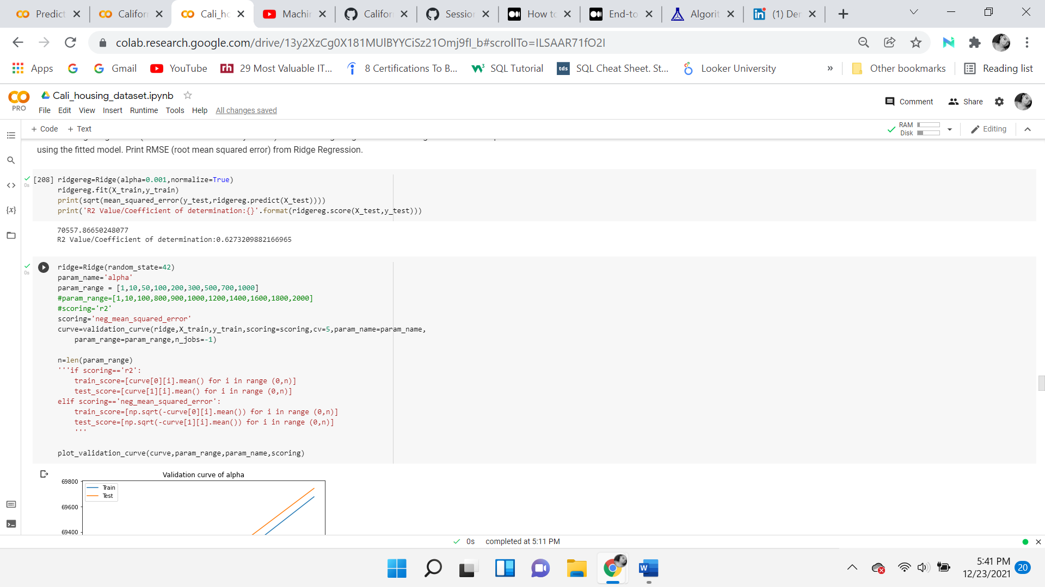

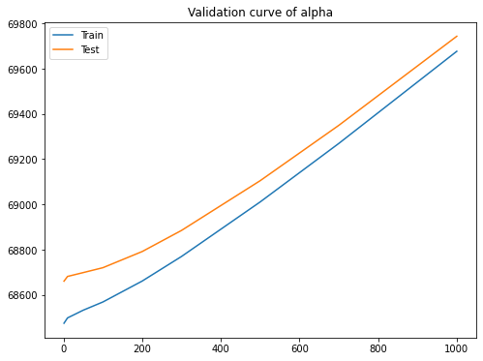

The graph above shows that both the train and test scores are above the alpha level of 700. Even at alpha set to 0, the difference between RMSE of the linear regression model is not much, so there is no objectionable overfitting. As alpha is increased, bias is increasing and so is the RMSE. As linear regression is not overfitting the model, using Ridge regression is not necessary. There doesn’t seem to have multicollinearity.

## 

## **Lasso Regression (L1 Regression)**

Lasso stands for least absolute shrinkage and selection operator. The model regression uses L1 regularization to force some coefficients to be exactly zero by shrinkage. The points can either be close to zero or zero. Which means they are either ignored or eliminated by the model. This can be used as a type of feature selection. Lasso has the potential to reveal the most important features. Using an alpha of 0 is not advised as this will give the same result as a linear regression model. In normalization,the regressors X will be normalized before regression by subtracting the mean and dividing by the L2 normalization. The lasso model has an increased Root mean squared error of 70548.401, which is not the best, and an R2 coefficient of determinate of 0.6274. This model was used to see if it improved from the linear model, but it did worse. An advantage of LASSO is that it can avoid overfitting and can work with a large number of features. A disadvantage is that LASSO “If there are two or more highly collinear variables then LASSO regression select one of them randomly which is not good for the interpretation of data” (Hui & Hastie, 2020)



## **Support Vector Regression**

This is a supervised machine learning algorithm for both classification and regression problems. The kernel trick with support vector machines and polynomial features was used on the RBF kernel. Radial Basis Function (RBF) kernel SVM. The aim is to create a marginal distance, which will convert a lower dimension into a higher dimensional model. The degree of the polynomial kernel function is 2. The model oversees separating the data into two classes. It does this by maximizing the marginal distance between the hyperplane and the nearest data points of either class. Support vectors are points that lay on the margin parallel to the hyperplane. Points on one side of the hyperplane are classified as -1 and the other said is +1. The distance in the margin is important, as the larger the marginal plane distance, the more likely the model will generalize and have the best accuracy. The Support Vector Classifiers account for outliers through the regularization parameter C, which is used to penalize misclassifications in the margin by a factor of C > 0. Which in this case identifies what the best param score is C of 100. This resulted in an R2 coefficient of determination of 0.55. An advantage is that “SVM is effective in cases where the number of dimensions is greater than the number of samples”. (Dhiraj, 2020) A disadvantage “SVM algorithm is not suitable for large data sets.” (Dhiraj, 2020)



**K-Nearest Neighbor**

K-Nearest Neighbor is a simple algorithm that stores all available cases and classifies new cases by a majority vote of its k neighbors. The case is most common amongst its K nearest neighbors measured by a distance. The distance can be measured with different metrics. The default metric in this model is Minkowski, which is used for real value vector spaces. Choosing K depends on the data. In this case, the chosen n neighbors are 10. All points in each neighborhood are weighted equally.

The mean squared error of the training set is 57843.541 and the mean squared error of the validation set is 64094.98, which are both high values, and being that the validation set is greater than the train set by over 6000, this indicates it’s overfitting. The mean squared error of the test set is 74819, which means this model performed very poorly. A coefficient of determination of 0.688. An advantage is “KNN is very **easy to implement**. There are only two parameters required to implement KNN i.e. the value of K and the distance function (e.g. Euclidean or Manhattan etc.)” (Kumar, 2019) A disadvantage is that it “**Does not work well with large datasets:**In large datasets, the cost of calculating the distance between the new point and each existing points is huge which degrades the performance of the algorithm.” (Kumar, 2019)

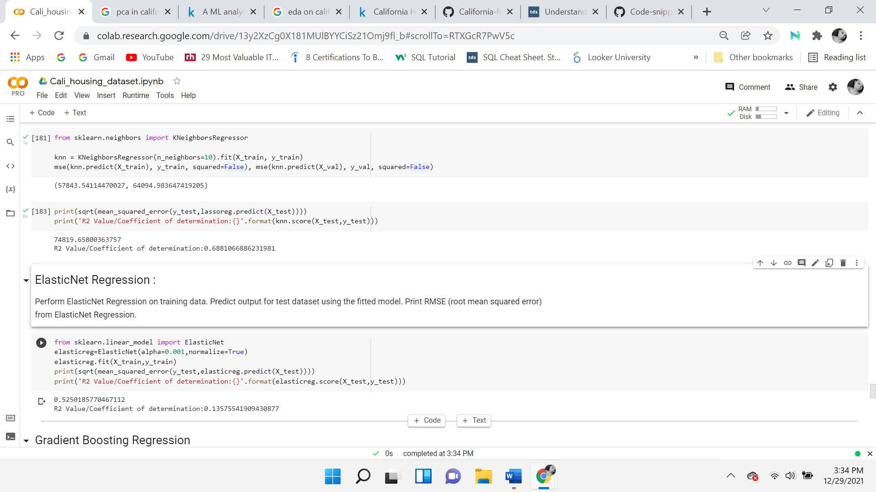

## **Decision Tree Regression**

The Decision tree algorithm is a supervised machine learning model. It begins with the root node. The root node is representative of either the population or the sample, in this case, the sample of the population. It then gets further divided into two or more decision nodes. The parent node is the node above the child node. When a node no longer splits it’s called the terminal or the leaf node, it is easier to identify because it’s at the ends. One downside of decision trees is that they are more prone to overfitting, almost as if they don’t know when to stop growing. Pruning a tree can be used to correct the model that overfits. It is the process of removing sub-nodes of a decision node to increase accuracy and give better predictions. Below cross-validation is used, which allows for the training set to be split into smaller sets known as folds. It will evaluate the decision tree 5 different times. An advantage is that “A Decision tree model is very intuitive and easy to explain to technical teams as well as stakeholders” (Dhiraj, 2020). A disadvantage is “The Decision Tree algorithm is inadequate for applying regression and predicting continuous values.” (Dhiraj, 2020)

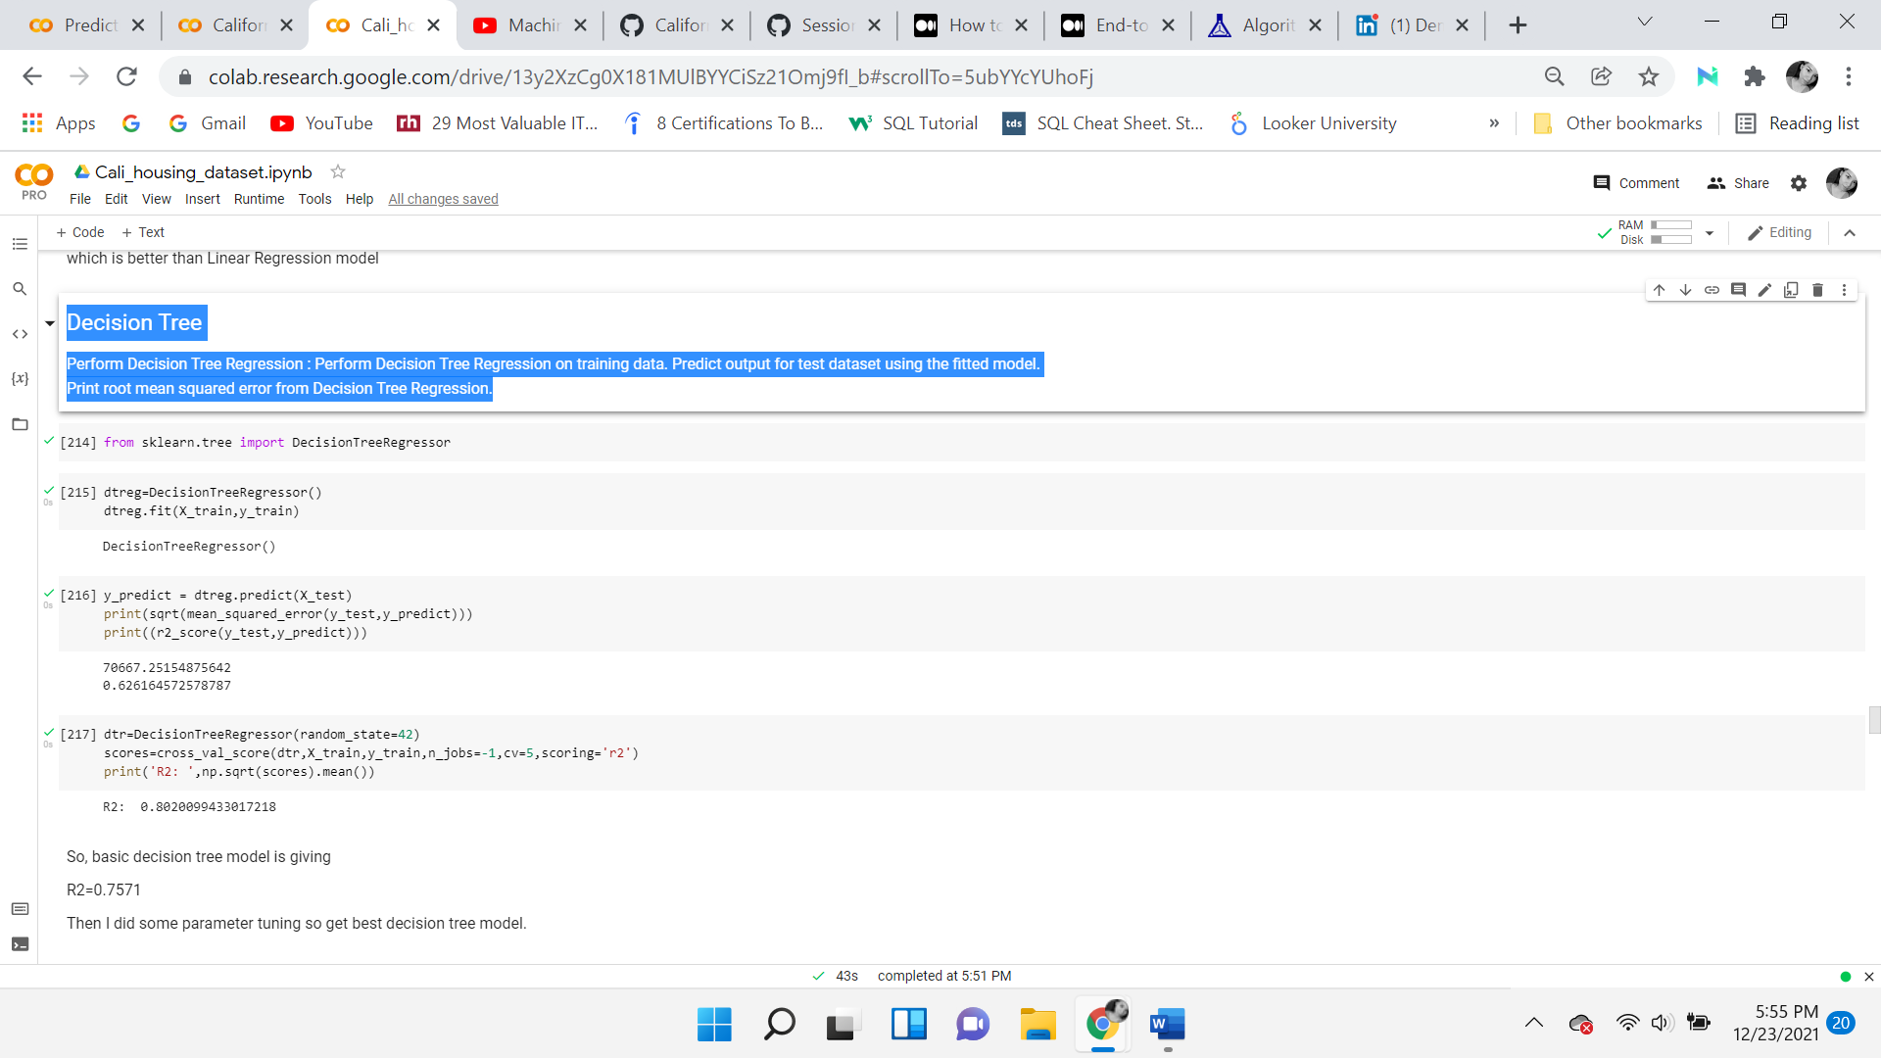

The root means squared error of the test set is 70667.251 and the R2 coefficient of determinate of 0.62616. For the training set, the R2 coefficient of determinate is 0.80, which is a good score, but the model is performing better on the training data than it is on the test data. Again, this is known as overfitting which is a common issue with decision trees. Below parameter tuning is performed on the decision tree to get a better outcome.

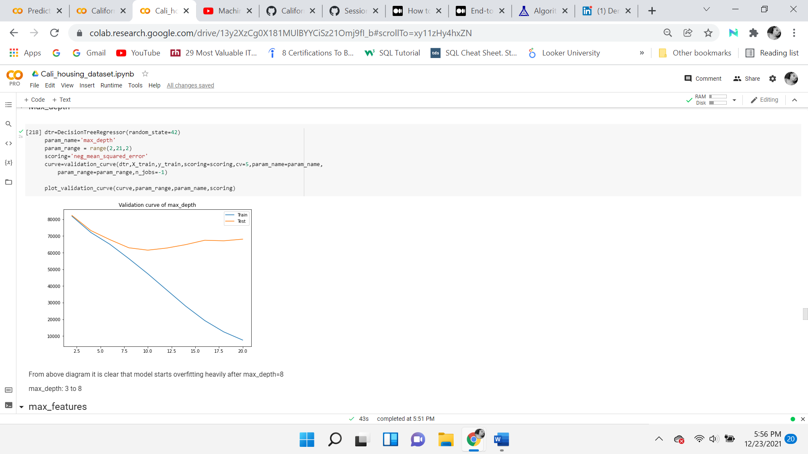

The graph indicates that the model begins to overfit after a max depth of 8. So, the max depth should be somewhere between 3 and 8.

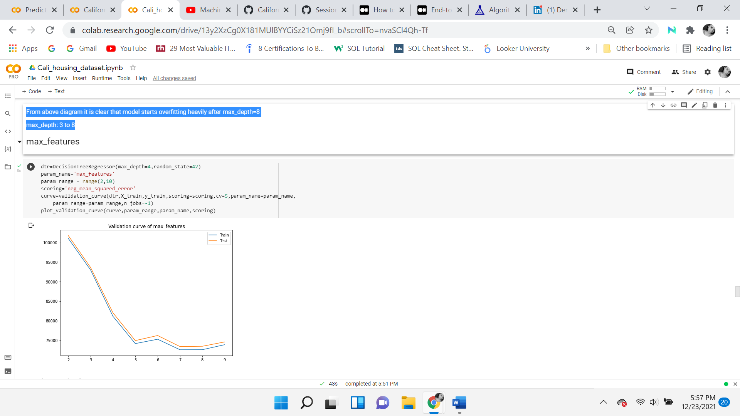

The graph indicates the max features should be from 6 to 9.

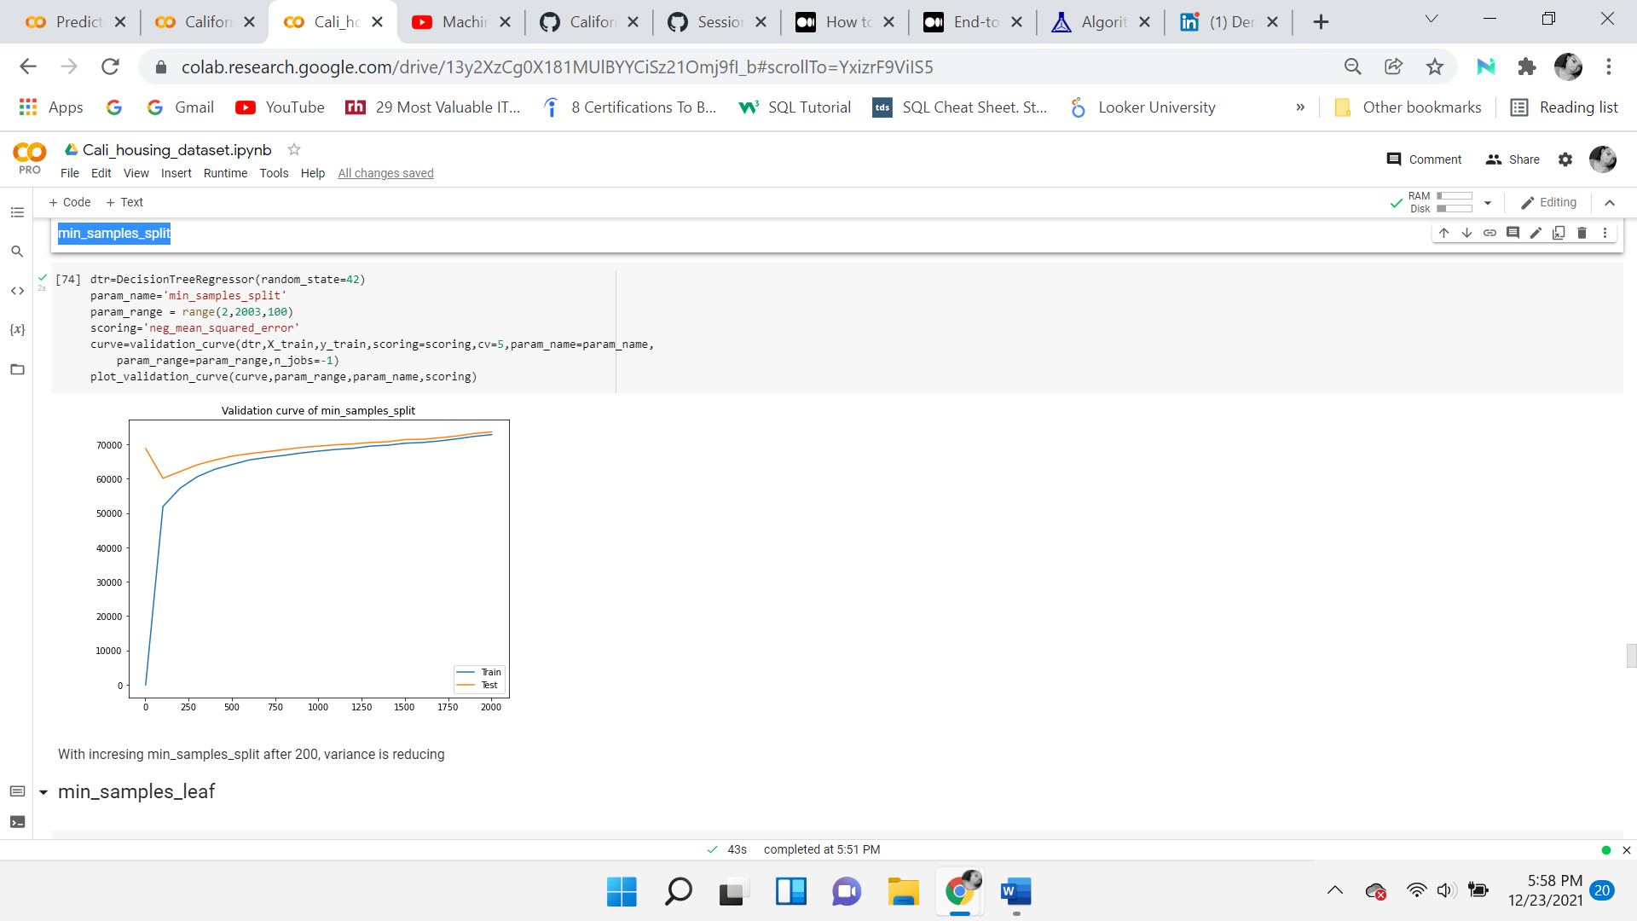

The illustration indicates that the min samples split starts to increase after 200, which indicates that the variance is reducing.

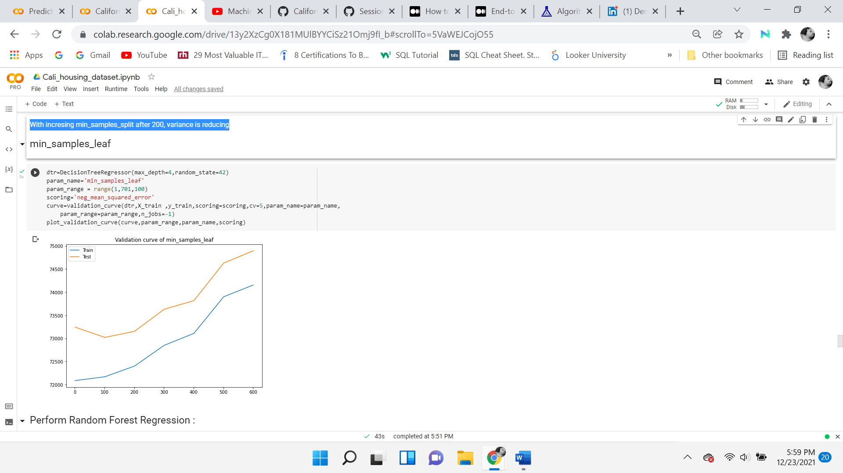

Increasing min samples leaf is neither giving good results nor helping to reduce overfitting.

**Random Forest Regression**

**Random Forest Regression** is a supervised learning algorithm that consists of multiple decision trees. Most decision trees have an increase in variance and when combined in a parallel way, the variance tends to decrease, which is what random forest is used for. Random forest is known as Ensemble Learning because it uses multiple decision trees as base learners, building models on top of models. It uses ensemble learning bagging, which is both bootstrapping and aggregation. An advantage is that “Random Forest can be used to **solve both classifications as well as regression problems”**.(Kumar, 2019) A disadvantage is “Random Forest require much more time to train as compared to decision trees as it generates a lot of trees (instead of one tree in case of the decision tree) and decides on the majority of votes.” (Kumar, 2019)

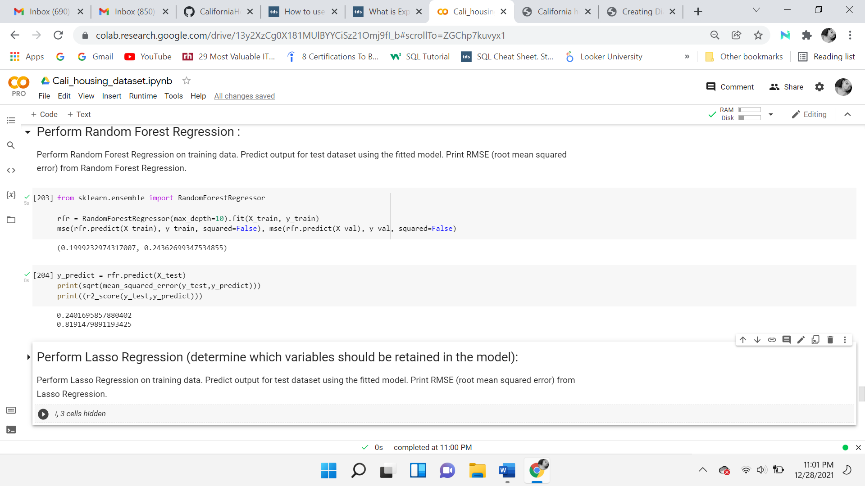

The mean squared error of the training set is 43549.732 and the mean squared error of the validation set is 52232. 466, which indicates that the model is overfitting. The difference between the train and validation is over 8600. Although the model is performing better than the rest of the models because it has a lower mean squared error, it is still overfitting. The root means squared error of the test is 55533.96, and the R2 coefficient of determinate of 0.7691.

## 

## **Gradient Boost Regression**

To get the best model from the decision trees, the ensemble method is applied. Finding hyperparameters is established using Grid Search, which will also do cross-validation. An advantage is that there is “Lots of flexibility - can optimize on different loss functions and provides several hyperparameter tuning options that make the function fit very flexible”. (Vihar, 2021) A disadvantage is that “Gradient Boosting Models will continue improving to minimize all errors. This can overemphasize outliers and cause overfitting.” (Vihar, 2021)



## ***Check for n_estimators***

With an increasing number of estimators, the model is overfitting. With a lower number of estimators, the model is underfitting. The chosen estimators are 250.

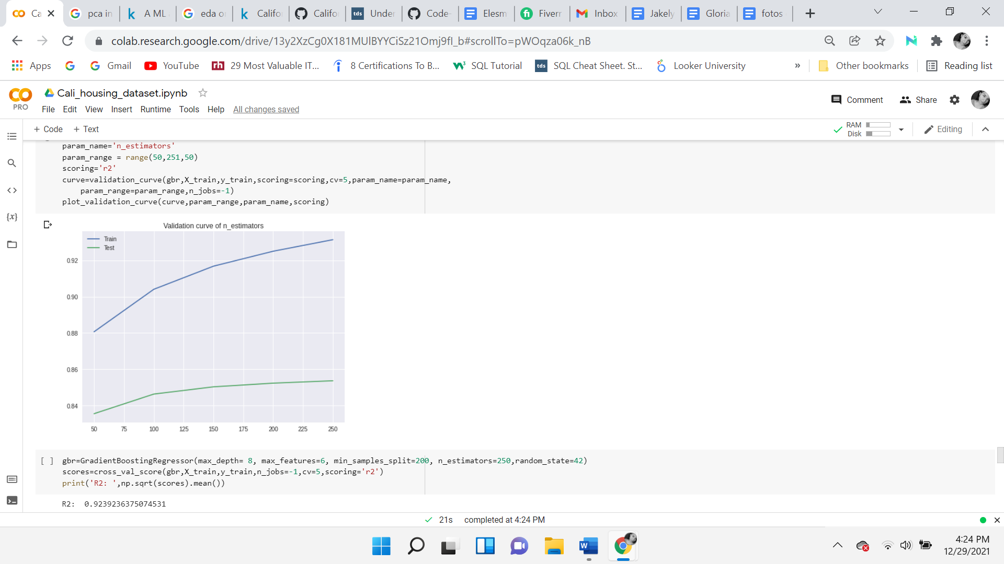

With the above Gradient Boosting model R2 of 0.92, best one yet. Although, it is overfitting.

**Artificial Neural Network, Deep Learning**

ANN is very much associated with machine learning as a subset, but it goes further into artificial intelligence. It uses the concept is to mimic the human brain to facilitate the modeling of arbitrary functions. The nodes or code structures are arranged in layers. Beginning with an input layer, next to a hidden layer, each layer’s input is the previous layer's output, which yields progressively higher-level features, ending with an output layer and defining a hierarchy.

The complexity of the model may be increased by adding more hidden layers and neurons. Although a Neural network is known as a universal approximator, which means it can do the job, no matter how complex the function. This doesn’t necessarily mean that it will do it right. Working with various models, ranging from simple to complex, the model continued to overfit the data. In the first simple model, the activation function ‘relu’.

An advantage is that “ANN learning methods are quite robust to noise in the training data. The training examples may contain errors, which do not affect the final output.” (Gupta, 2020) A disadvantage is that “There is no specific rule for determining the structure of artificial neural networks.” (Gupta, 2020)

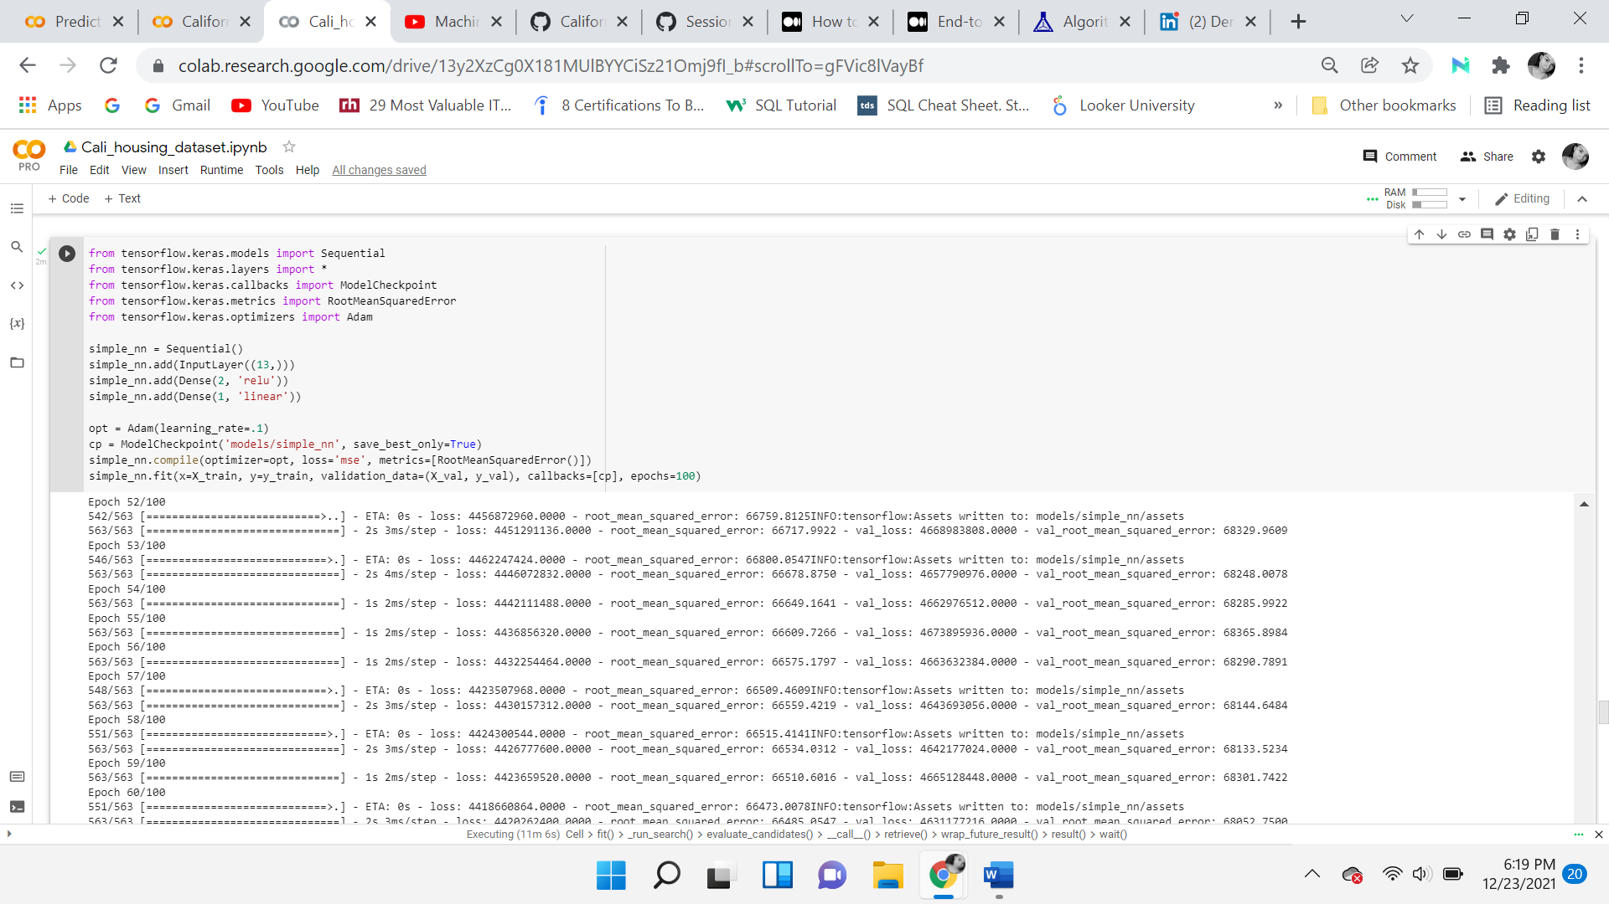

The model is not great, it's underfitting. The number below is close, both should go down. The error is too high.

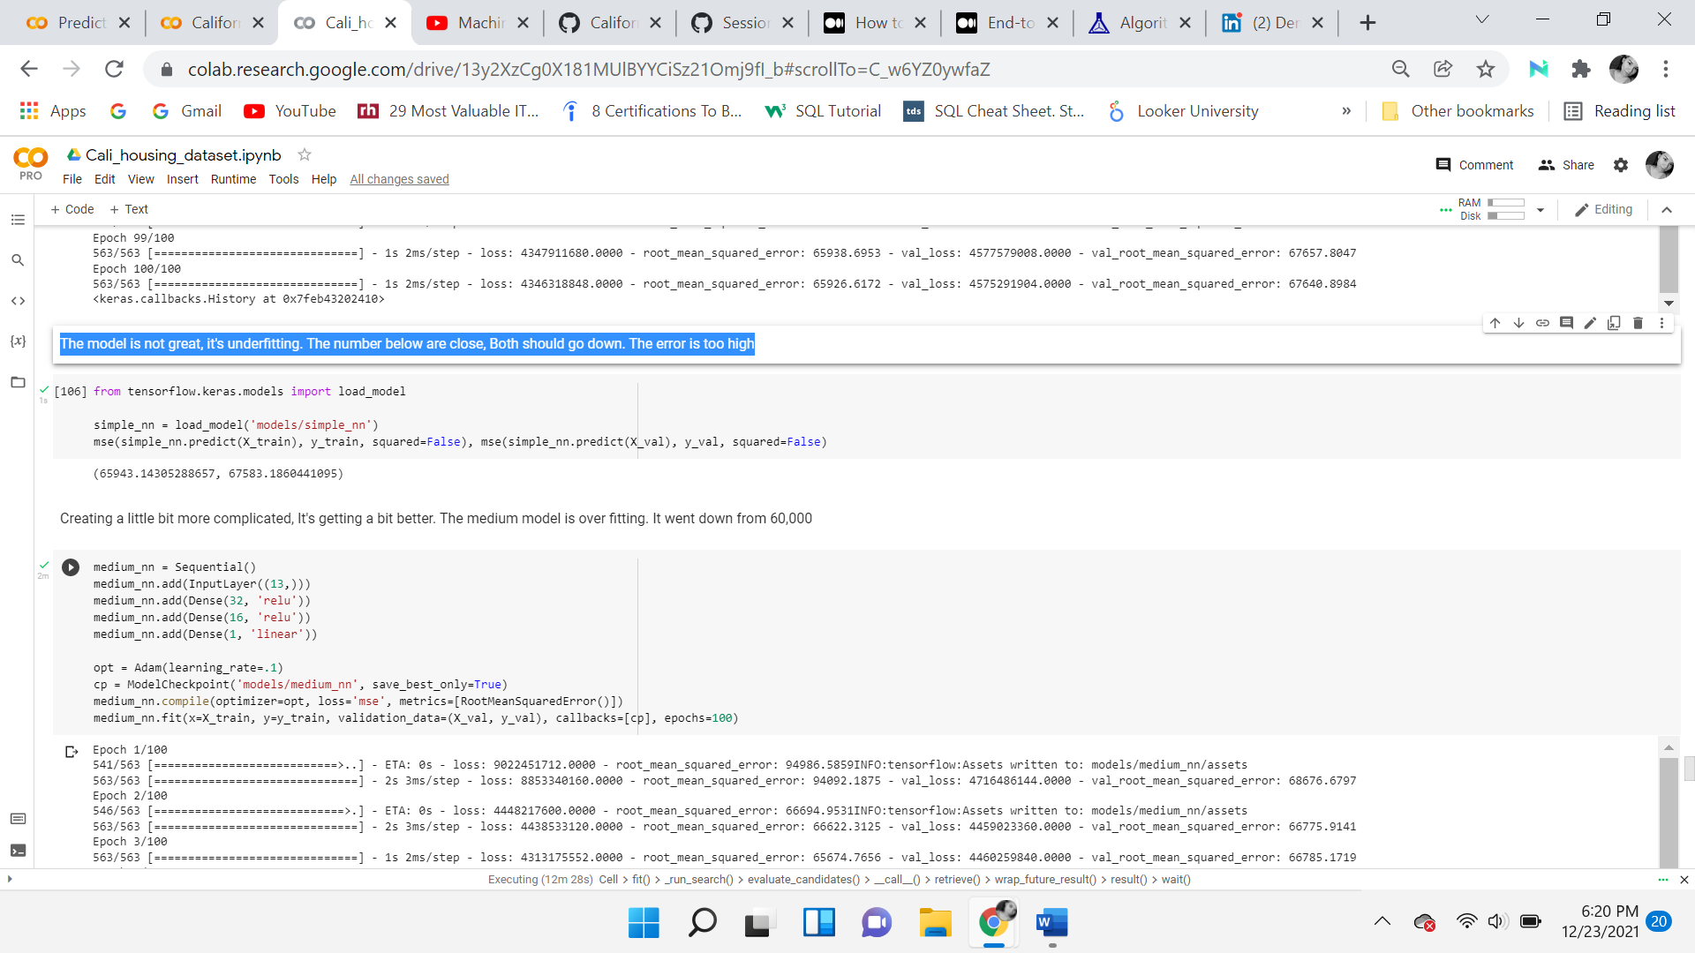

Next a little bit more complicated model is created, it’s getting a bit better. The medium model is overfitting. It went down from 60,000.

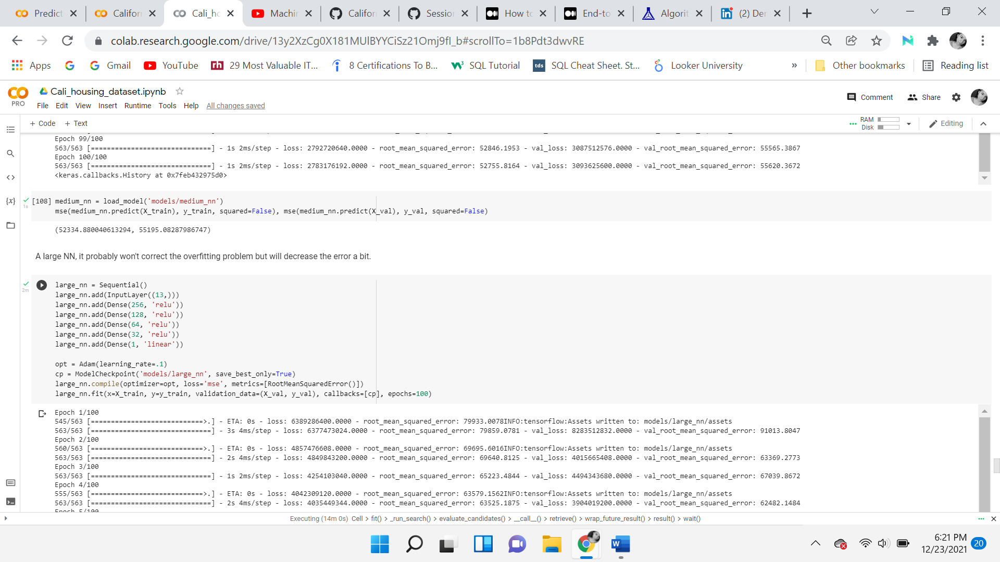

A large NN, probably won't correct the overfitting problem but will decrease the error a bit.

Down to 52,000 which is good, but it is overfitting.

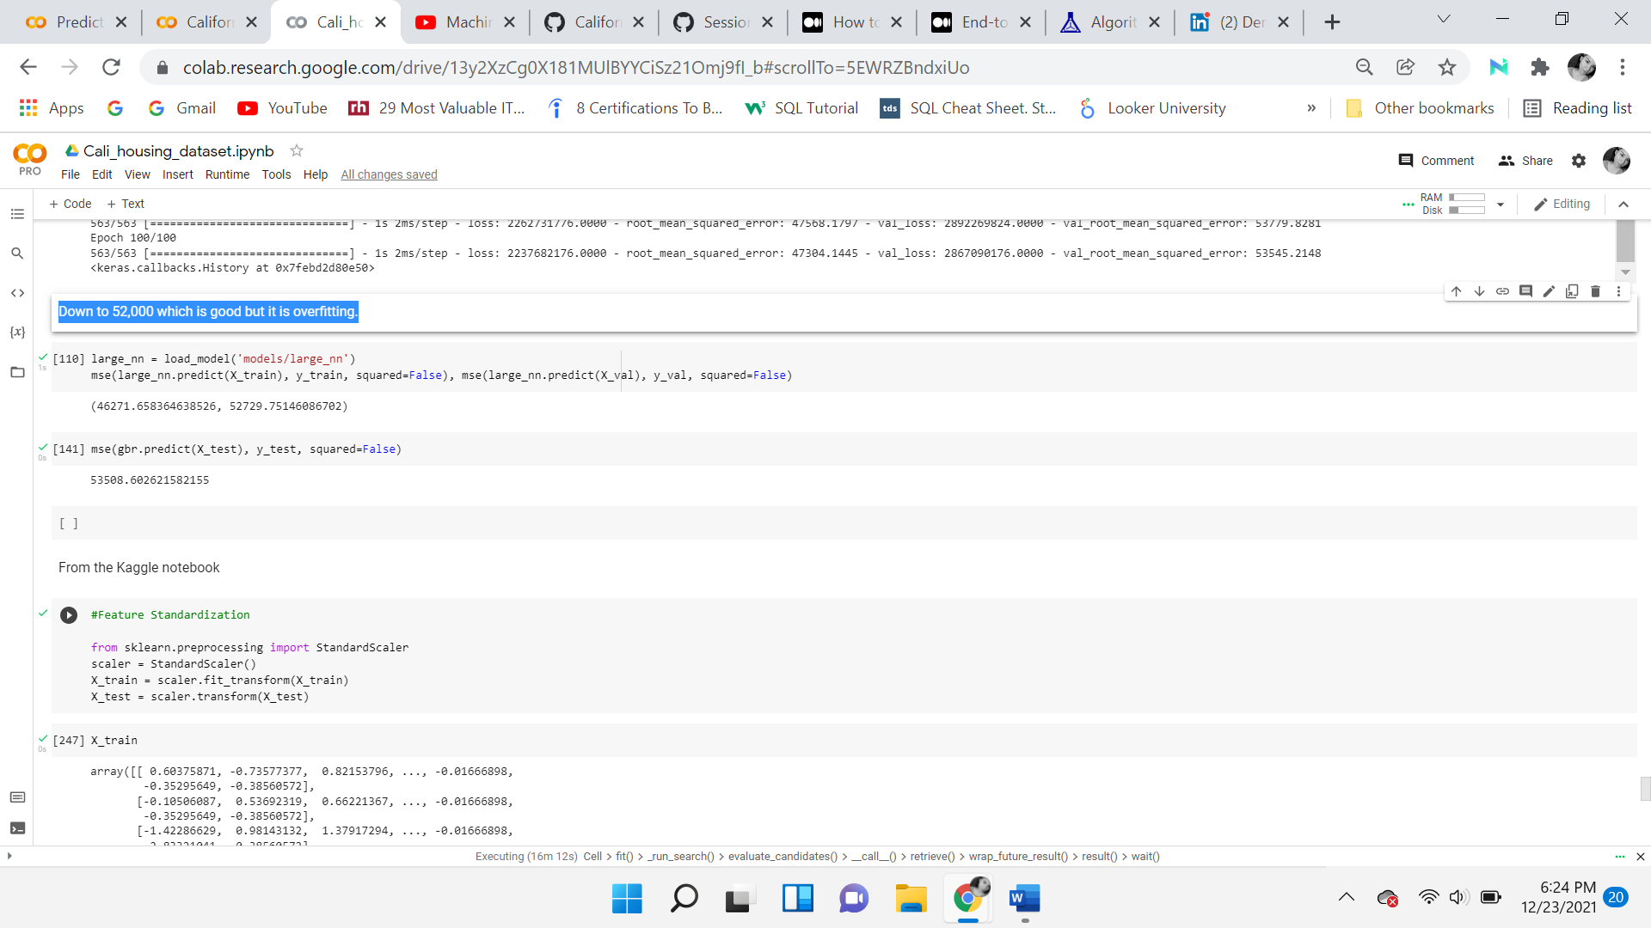

***Final Test Predictions***

The final test results will usually be slightly worse than what you measured using cross-validation if you did a lot of hyperparameter tuning. This is due to the machine being fine-tuned to the train and validation data, so it does not do as well on data that is unfamiliar. Comparing the two models that performed the best in the training phase. It turns out that random forest did better than gradient boosting. The test means squared error of the gradient boosting regression is 51400, while the Random Forest is 28369.

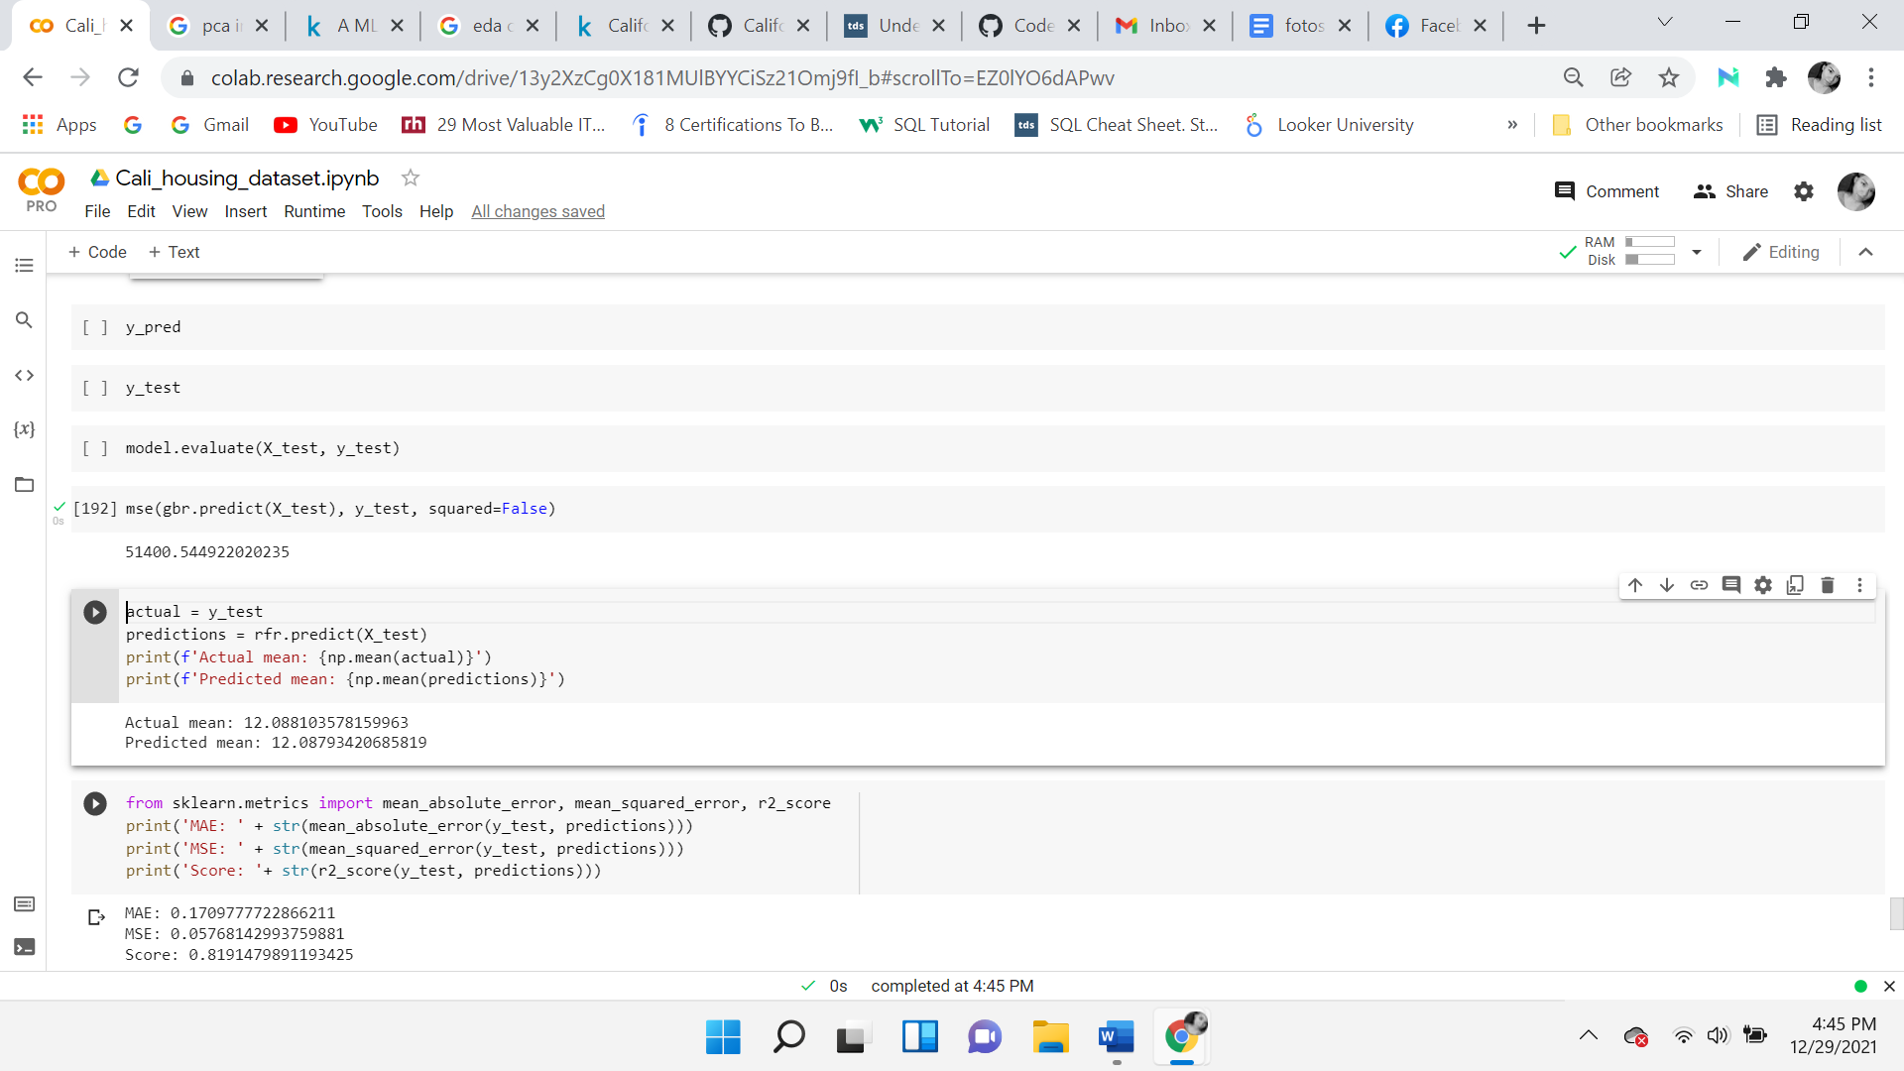

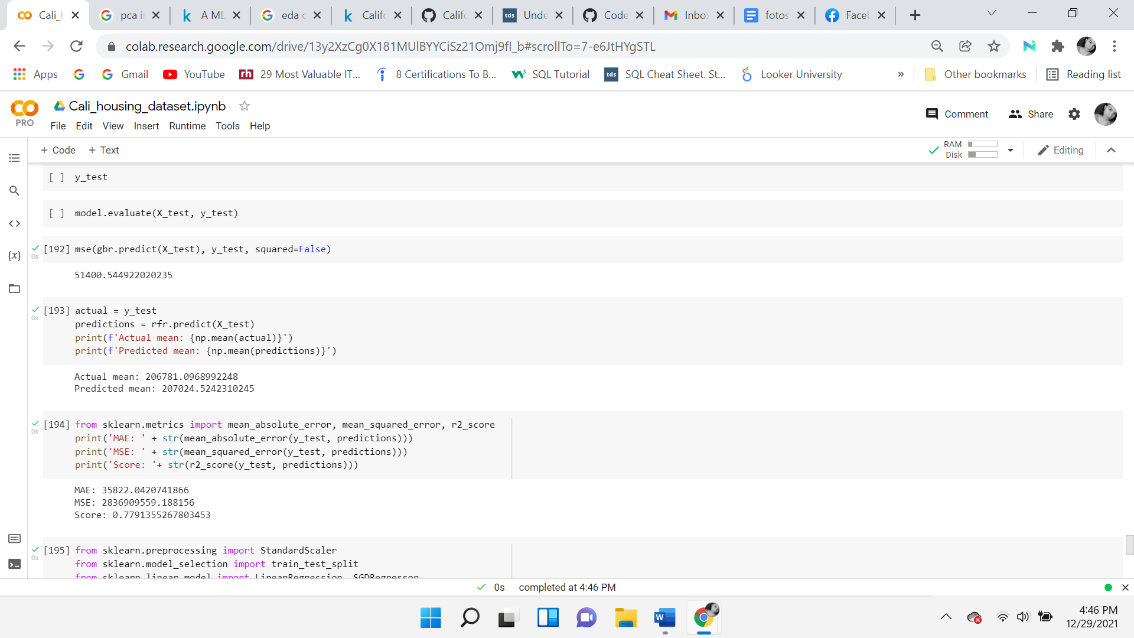

**Data Summary and Implications**

The data analysis implied that there is a significant relationship between the target variable, median home value, and the independent variable, median income. In testing the hypothesis and extracting the p-values, the null hypothesis was rejected. This indicated a statistically significant relationship between the two variables. Support for the alternative hypothesis is found in the article, *Housing price in South Bay*, where the author performs various statistical analyses on the California Housing dataset, after performing a standard linear regression he states “the ‘housing median value’ variable was selected as a dependent variable. From the results, the Households, the Median-Income, and the Population are all statistically significant. This is because both p-values ​​are less than 0.05.” (Jang, 2021)

One limitation was the way some features were grouped, scaled, and capped. The dataset consists of blocks of people and the median home value feature was the average of one particular block. Essentially, a better model could be created if a single observation consisted of single house values, of one house within a block. This could achieve a higher level of accuracy and a better prediction. Throughout the research, median income continuously indicated a strong relationship with the target variable. One of the objectives was to find variables that would be useful in the model so that it would be able to accurately predict home prices.

Depending on the business's goal and objective, they will decide whether to proceed with this model. Stakeholders should determine which level of accuracy they are okay with, either accept the error terms or continue to train the model. If the decision is to deploy the model, it is important to remember that the machine learning model needs iteration. When launching, always maintain and monitor. These models should not be left alone, they should be checked on regularly. They should be maintained using any new data available to ensure the accuracy of the predictions.

**Future Approach**

The first recommendation includes finding, using, and analyzing the most recent data in the field of study. Then building upon the research done in this project. Another approach is addressing the limitation of this research, which was how the data was calculated. This could be addressed by finding data that is in its most raw form. Data that presents the value of the house of each home on the block. Although this can be time-consuming, it will provide the most accurate predictions.

**Sources**

Barry, R., & Pace, R. K. (1997, May 5). *California housing*. Bem vindo. Retrieved January 7, 2022, from <https://www.dcc.fc.up.pt/~ltorgo/Regression/cal_housing.html>

Costa, C. D. (2020, August 21). *Python vs(and) R for data science*. Medium. Retrieved January 7, 2022, from <https://towardsdatascience.com/python-vs-and-r-for-data-science-4a32580846a4>

developers, google. (2020, February). *California housing data set description  |  machine learning crash course  |  google developers*. Google. Retrieved January 7, 2022, from <https://developers.google.com/machine-learning/crash-course/california-housing-data-description>

Heyman, A. V., & Sommervoll, D. E. (2019, June 28). *House prices and relative location*. Cities. Retrieved January 7, 2022, from <https://www.sciencedirect.com/science/article/pii/S0264275118312241?via%3Dihub>

Jang, H. (2021, November 29). *Housing price in South Bay*. ArcGIS StoryMaps. Retrieved January 7, 2022, from <https://storymaps.arcgis.com/stories/7b6a756bded44d5ba9ab574d56559044>

Komagome-Towne, A. (2016). *Models And Visualizations For Housing Price Prediction* (thesis). Department of Mathematics and Statistics, Pomona <https://broncoscholar.library.cpp.edu/bitstream/handle/10211.3/185729/KomagometowneAnh_Thesis2016.pdf?sequence=4>

Nugent, C. (2017, November 24). *California housing prices*. Kaggle. Retrieved January 7, 2022, from <https://www.kaggle.com/camnugent/california-housing-prices>

Zhang, Q. (2021, October 29). *Housing price prediction based on multiple linear regression*. Scientific Programming. Retrieved January 7, 2022, from <https://www.hindawi.com/journals/sp/2021/7678931>

developers, google. “Colaboratory .” *Google Colab*, Google, 2018, <https://research.google.com/colaboratory/faq.html#:~:text=Colaboratory%2C%20or%20%E2%80%9CColab%E2%80%9D%20for,learning%2C%20data%20analysis%20and%20education>.

Dhiraj, K. “Top 4 Advantages and Disadvantages of Support Vector Machine or SVM.” *Medium*, Medium, 26 Dec. 2020, <https://dhirajkumarblog.medium.com/top-4-advantages-and-disadvantages-of-support-vector-machine-or-svm-a3c06a2b107>

Dhiraj, K. “Top 5 Advantages and Disadvantages of Decision Tree Algorithm.” *Medium*, Medium, 26 Dec. 2020, <https://dhirajkumarblog.medium.com/top-5-advantages-and-disadvantages-of-decision-tree-algorithm-428ebd199d9a>

Gupta, Srajan. “Advantages and Disadvantages of Artificial Neural Networks.” *Asquero*, 22 Aug. 2020, <https://www.asquero.com/article/advantages-and-disadvantages-of-artificial-neural-networks/>

Kumar, Naresh. “Advantages and Disadvantages of KNN Algorithm in Machine Learning.” *Advantages and Disadvantages of KNN Algorithm in Machine Learning*, <http://theprofessionalspoint.blogspot.com/2019/02/advantages-and-disadvantages-of-knn.html>

Kumar, Naresh. “Advantages and Disadvantages of Random Forest Algorithm in Machine Learning.” *Advantages and Disadvantages of Random Forest Algorithm in Machine Learning*, 23 Feb. 2019, <http://theprofessionalspoint.blogspot.com/2019/02/advantages-and-disadvantages-of-random.html>

Kurama, Vihar. “Gradient Boosting for Classification.” *Paperspace Blog*, Paperspace Blog, 9 Apr. 2021, <https://blog.paperspace.com/gradient-boosting-for-classification/#:~:text=Advantages%20and%20Disadvantages%20of%20Gradient%20Boost,-Advantages%20of%20Gradient&text=Often%20provides%20predictive%20accuracy%20that,the%20function%20fit%20very%20flexible>

Nurfikri, Fahmi. “Build Code Collaboration with Google Colab.” *Medium*, Towards Data Science, 25 Oct. 2020, <https://towardsdatascience.com/an-effective-way-of-managing-files-on-google-colab-ac37f792690b>

Vidvan, T. “Python Advantages and Disadvantages - Step in the Right Direction.” *TechVidvan*, 28 Sept. 2021, <https://techvidvan.com/tutorials/python-advantages-and-disadvantages/#:~:text=We%20discussed%20above%20that%20Python,extra%20work%20while%20executing%20code>

Zou, Hui, and Trevor Hastie. “Lasso vs Ridge vs Elastic Net: ML.” *GeeksforGeeks*, 12 Mar. 2020, <https://www.geeksforgeeks.org/lasso-vs-ridge-vs-elastic-net-ml/>